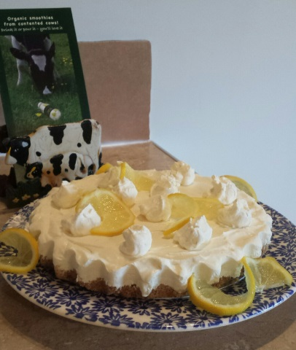
Carolyn’s Lemon Cheesecake
Ingredients: 175 gm digestive biscuits crushed 75 gm butter melted 40 gm demerara sugar
160 gm (one pot) Court Lodge Organic Labneh 25 gm caster sugar 150 ml double cream 200 ml full fat crème fraiche 1 large lemon – zest and juice
Method: Firstly, lightly grease a 20 cm loose bottom tin with butter. Then thoroughly mix the crushed biscuits, demerara sugar and melted butter together and then press into the bottom of the loose bottom tin. Place in fridge to cool while the filling is being made. For the filling, whip the double cream until stiff then add the Court Lodge Organic Labneh, crème fraiche, caster sugar and zest and juice of a large lemon. Ensure all is mixed well with no lumps before placing on top of the biscuit base. Chill in fridge for a few hours.
You can decorate the cheesecake with small blobs of whipped cream and slices of lemon as shown.

