**Patchurst Marsh Invertebrate Survey**

Graeme Lyons, January 2015

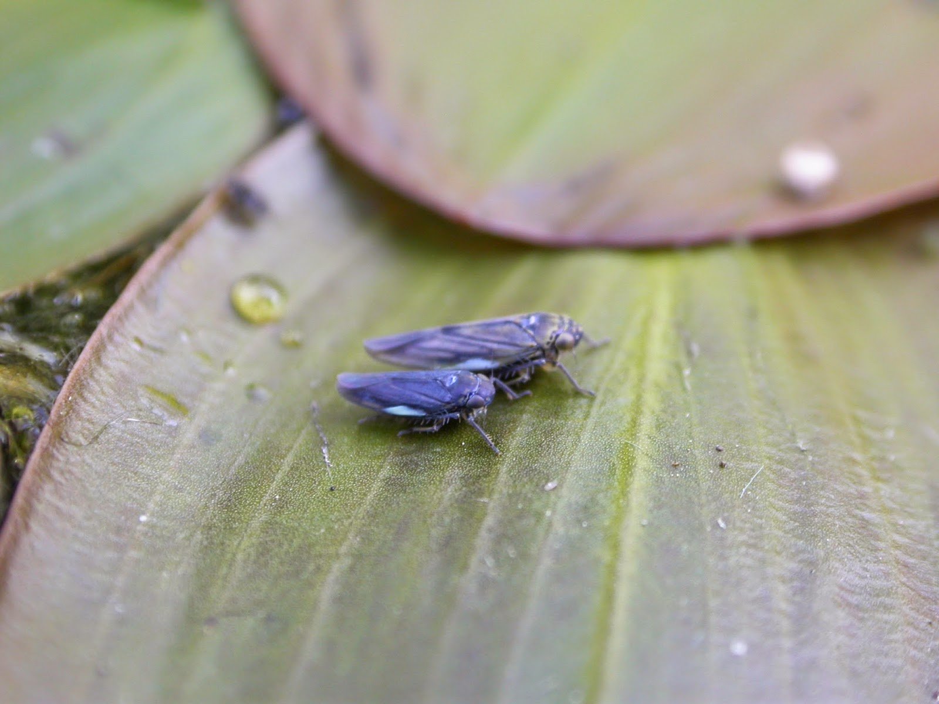

**0 – Summary**

Patchurst Marsh is a private nature reserve adjacent to the Pevensey Levels SSSI in East Sussex. The ponds were created in 2009 and were therefore, at the time of surveying, only five years old. The ponds were created on a 7.3 ha field that was previously arable and then grassland.

The author was commissioned to carry out a full invertebrate survey of the ponds with a focus on aquatic invertebrates. Six visits were made between April and September and only warm, sunny and calm days were used. On each of five ponds labelled 0 to 4, 30 minutes of recording was carried out. A mixture of methods were used including sweeping, netting, pond-netting, sieving and active searching. The methods that were most appropriate for the season were used.

An accumulative spreadsheet was made and the species present on each visit were added to this so that for each pond a species list was drawn up. All 676 records were submitted to the Sussex Biodiversity Records Centre.

A total of 325 species of invertebrate were recorded the largest order being beetles with 144 species. A total of 94 species could be considered truly aquatic and of these 41 were beetles and 18 aquatic bugs. A total of 21 (6.5) species had conservation statuses. Collectively the ponds scored high for their Community Conservation Score with 34.5 showing national significance.

The rarest species was perhaps the Pondweed Leafhopper *Eretottix cyane* as this site is now only the seventh known site for this species. Other highlights included the 13-spot Ladybird *Hippodamia tredecimpunctata* and Lesser Water-measurer *Hydrometra gracilenta*.

The site has an exceptional fauna considering it is only five years old but this is in part due to the close proximity to Pevensey Levels SSSI.

Recommendations for management based upon the survey’s findings and observations in the field are also provided.

**1 – Introduction**

Reedbed creation, Court Lodge Farm (from David and Marian Harding)

The 18acre (7.3 ha) field where the reedbed was created was in permanent arable production for at least 26 years, having been under drained in the early 1970s. The following is a potted history in the form of a timeline

* 1972-1998 - arable cultivation, mainly winter wheat and break crop of fodder beans.
* 1998 - reseeded with grass mix under set-aside.
* 2002 - grass and white clover mix over seeded, grazed and cut for hay.
* Small pond made at southern end.
* Small scrape made in northern end.
* 2009 - After consultations with RSPB (Matt Self), Natural England and EA, and David Harding attending 2 RSPB reedbed courses, the levels were surveyed by John Hayward of Clarity Ecoworks and he and David made a plan. The 18 acre field known as Patchurst Marsh was chosen for various reasons including the fact that it was adjacent to, but not within, the SSSI, so avoiding the need for permits/consents from NE. Also, it could be managed and grazed independently of surrounding fields.
* 21.8.09-7.11.09 Reedbed created on c 8 acres under HLS agreement dated 1.8.09. option HQ5 'creation of reedbeds' .
* Robins of Herstmonceux were contracted to do the large scale earthmoving and John Hayward and David Harding the finishing touches.
* All topsoil was removed from the planned reedbed to a depth of 18".
* Clay subsoil was also removed and taken to fill in a large hollow in the steeply sloping field above - topsoil in the infill area was first stripped back, and then replaced on top of the clay.
* The subsequent areas designated for reed were only dug out a further 6" or so, but 4 ponds were created with interconnecting channels. Ponds 1, 2 &4 were dug out by another 4' or so, with the interconnecting channels a similar amount. Pond 3 was dug to 5-6 ft deep with an island left in the middle!
* The reed areas were scuffed about a bit to create an uneven surface and some very small pools were dug into them randomly. Next, some topsoil and reed rhizomes were transported back to the reed areas and spread about using a small hymac. This soil was taken from existing areas of reed (by scrape, pond and ditch margins).
* All 4 ponds were connected by 4" pipes with bends so that individual pond levels can be altered.
* The 3 main field drains from the sloping field above were all cut off where they enter the reedbed so that all the water stays there. Also, field drains from the next field over were diverted into the reedbed.

Finally, on the eastern side, a perimeter trench (about 3-4 ft down) was cut to cut off any missed drains and to provide a different habitat. Everything was left to fill up with rainwater, which it did in about 3 weeks.

Subsequent management has been mainly pulling out volunteer willow saplings which threatened to take over, this has been done every autumn (Sept/Oct) by BTCV (now TCV). The grassy areas between the reedbeds have been cut for hay, and cattle let in late in the year to graze and puddle the reedbed.

Pond 1

Pond 2

Pond 3

Pond 4

Pond 0

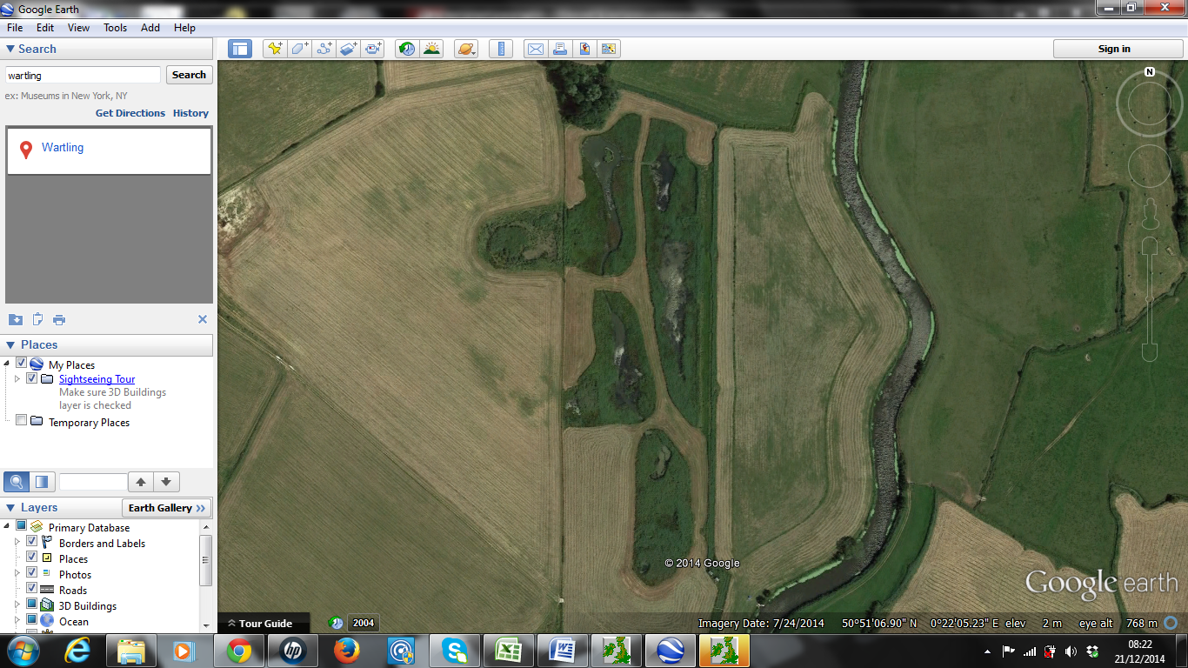

**Fig 1.** The five ponds at Patchurst Marsh.

**2 – Methodology**

Each of the five ponds (numbered 0 to 4) were visited for 30 minutes during each of the six visits. For each pond, an accumulative list was collated in Excel. These five lists fed into a master list for the whole site. Species recorded in the grassland adjacent to the ponds were added to the nearest pond.

Specimens that could not be identified in the field were taken away for microscopic identification.

Pond netting, sweeping, sieving and searching flowers and bare mud were the main methods used and were seasonal in nature. Pond-netting and sieving were focused on the early and late visits while sweeping was the predominant method in the summer months.

The dates of the six visits were:

1. 19th April
2. 18th May
3. 21st June
4. 29th July
5. 20th August
6. 28th September

**3 – Results**

**3.1 – Summary of findings**



**Fig. 2.** Break down of the species recorded at Patchurst Marsh.

A total of 325 invertebrates were recorded during the survey. Beetles accounted for 45% of the species recorded. Of this, 21 species had a conservation status equating to 6.5% of all species recorded.

A total of 41 water beetles and 18 aquatic bugs were recorded.

Large water beetles were thin on the ground. Only two individuals of *Dytiscus marginalis* were found throughout the whole survey and no larvae were recorded. Surprisingly no Great Silver Diving Beetles or their distinctive larvae were recorded despite being abundant on the adjacent levels.

Arachnids were also surprisingly under-represented. This could be due to the relative lack of structural diversity and is likely to increase as the reedbeds get older and more varied. Fen Raft Spiders were also not recorded but are abundant on the adjacent levels.

**3.2 – Species with conservation statuses**

Some of the following photographs were taken on site and some are stock photos from the author’s library of images. The author is more than happy for the photographs used in any way to promote the conservation interest of the site.

* Pondweed Leafhopper *Eretottix cyane* – RDB Data Deficient BAP



**Fig. 2**. Two Pondweed Leafhoppers sitting on the leaves of Broad-leaved Pondweed on the northern edge of pond 1.

This was the surprise find of the survey for quite unusual reasons. On the 21st June, Seth Gibson stood looking at the patch of Broad-leaved Pondweed at the southern end of pond 2 and jokingly said, “look there’s one of those blue leafhoppers”. There was nothing there, as this particular leafhopper was so rare it was only known from six ponds. During the next visit on the 29th July on the patch of pondweed at the northern end of pond 2 we recorded hundreds of specimens. Ironically they were probably there behind Seth (about five metres away) back in June. This is only the seventh known pond for this in the UK. During the August visit, only a small number of specimens were recorded on pond 1 but a single specimen was recorded on a patch of pondweed on the north western side of pond 4. No specimens were recorded in August. A national expert, Dr Alan Stewart from the University of Sussex accompanied me and Dr Mark Telfer to see the site in August based upon this and the following species.

More information can be found on this species on the Fresh Water Habitats’ species dossier here:

http://www.freshwaterhabitats.org.uk/wordpress/wp-content/uploads/2013/09/Pondweed-Leafhopper-new-logo.pdf

* 13-spot Ladybird *Hippodamia tredecimpunctata* – RDB Data Deficient

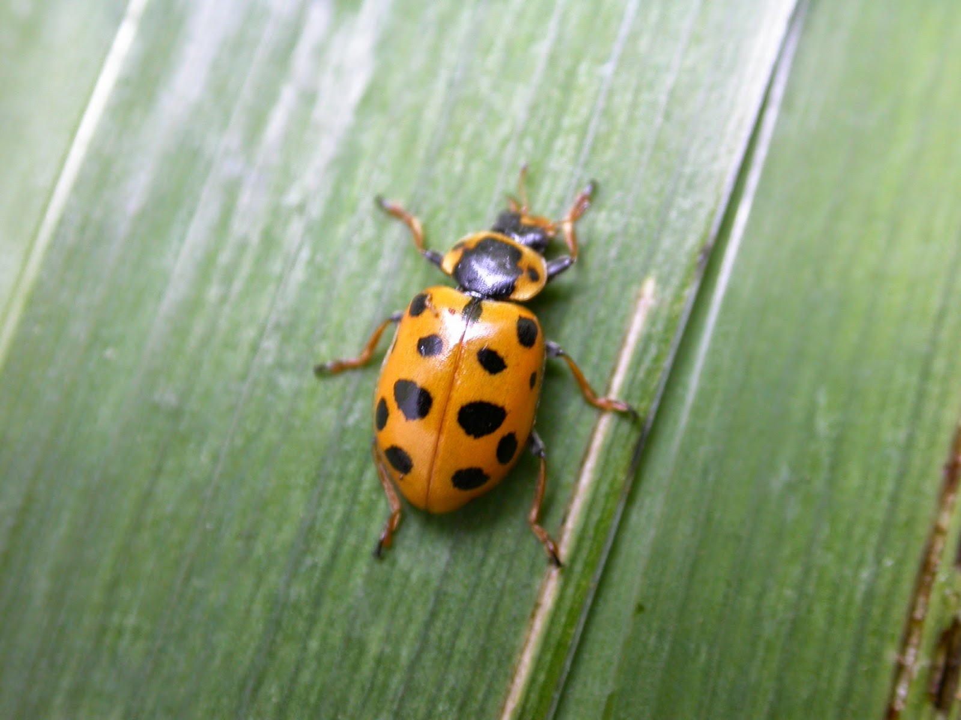

**Fig. 3.** 13-spot Ladybird

All specimens were recorded by sweeping reed and other emergent plants on the edge of pond 2. Recorded from June to August and peaking in July, this very rare wetland ladybird is almost certainly established on the site rather than just being a migrant.

* Lesser Water-measurer *Hydrometra gracilenta* – RDB BAP

This is the much rarer relative of the common Water-measurer which was also recorded at the site. Pevensey Levels is one of the few strongholds for this species in the country so it was not hugely surprising to find this species there.

* Four-lined Horsefly *Atylotus rusticus* – RDB Endangered

A large and striking horsefly with huge green eyes. This is another rare Pevensey Levels specialist. The author has recorded it from the nearby Pevensey Levels Sussex Wildlife Trust Reserve, Friston Forest and the Crumbles at Eastbourne. During this survey a single specimen was netted in grassland on the western edge of Pond 1.

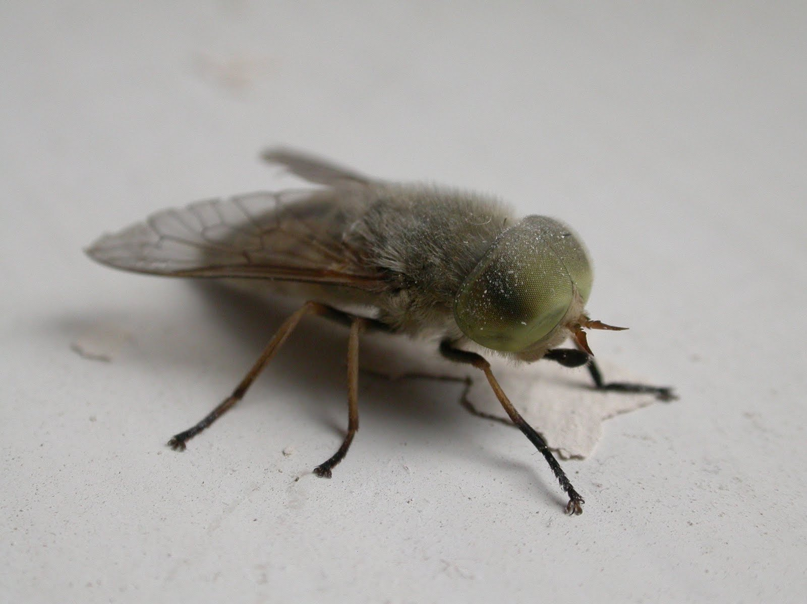

**Fig. 4.** *Atylotus rusticus* (stock photo).

* *Hydrochus elongatus* – IUCN RDB – Near Threatened

A single specimen was found by pond netting in pond 4 in July. This species is often associated with reedbeds. This species, along with the following species, were recorded by Jeremy Biggs on 31st July 2010.

* *Limnoxenus niger* – Nb – Near Threatened

Although once considered nationally rare, this water scavenger beetle has been downgraded to Nb. It was quite abundant in the ponds throughout the year, again Pevensey Levels is a known hot spot for the species. It was recorded in all but Pond 1 but this is probably just an oversight.

* Long-horned Mining Bee *Eucera longicornis* – Na BAP

A single male specimen of this striking bee was netted near the north west side of Pond 2 during the June visit. Having no connection with wetlands, this species is a real indicator of the quality of the grassland between the ponds.

* *Gyrinus paykulli* – Na

A single specimen was recorded by pond netting between reeds in September. This species is more parallel sided and elongate than the common whirligig beetle and is known as a reedbed specialist. It requires dissection of a male to confirm its identity.

* *Neophytobius quadrinodosus* – Na

This tiny weevil was recorded on the 18th May on pond 0.

* *Tetragnatha striata* – Nb

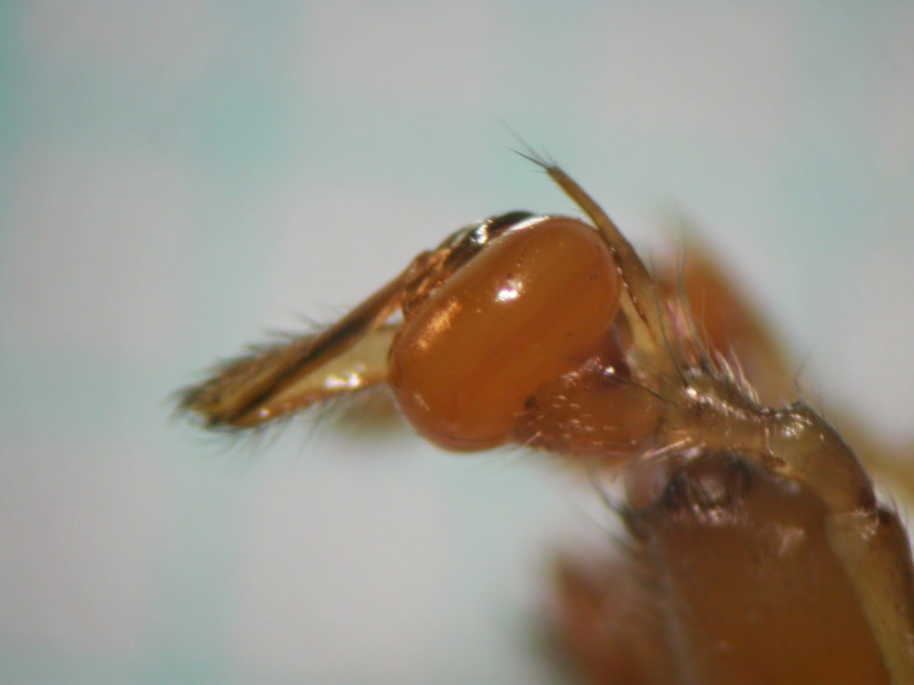

**Fig. 5.** A microscope view of the male palp of *Tetragnatha striata*

Found by sweeping on ponds 2, 3 and 4. This is the largest of the ‘large-jawed orb weavers’ and the author has only ever recorded this species from the edge of Burton Pond in West Sussex.

* *Demetrias imperialis* – Nb

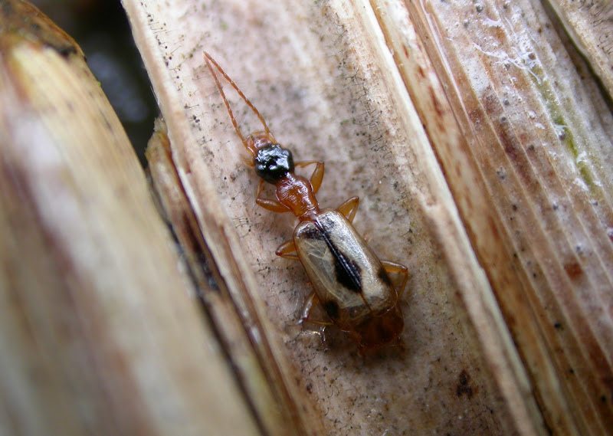

**Fig. 6**. *Demetrias imperialis* (stock photo).

Found on ponds 0, 1 and 4. Found throughout the whole surveys season both by sweeping and sieving. This highly distinctive reedbed specialist carabid is found abundantly in the area where reed grows.

* *Donacia crassipes* – Nb

This is just one of the six species of *Donacia* (reed beetle) recorded during the survey. They are not all reed specialists but *Donacia crassipes* is. It is easily identifiable by its all red legs.

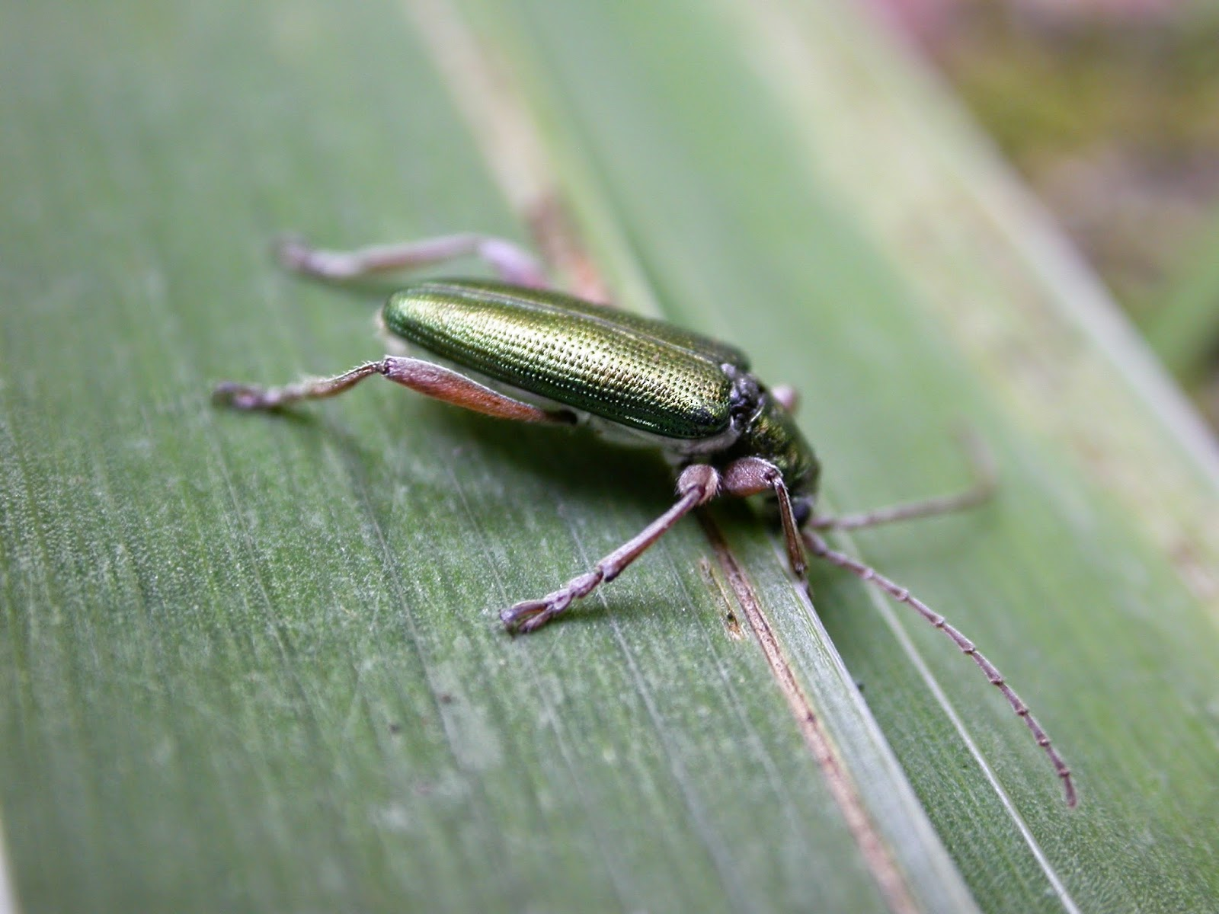

**Fig. 7.** *Donacia crassipes* (stock photo).

* *Donacia thalassina* – Nb

A scarce *Donacia* that feeds mainly on sedges but also on other emergent aquatic plants.

* *Silis ruficollis* – Nb

This wetland specialist soldier beetle was present on ponds 2 and 4 and was found by sweeping.

* *Stenus fornicatus* – Nb

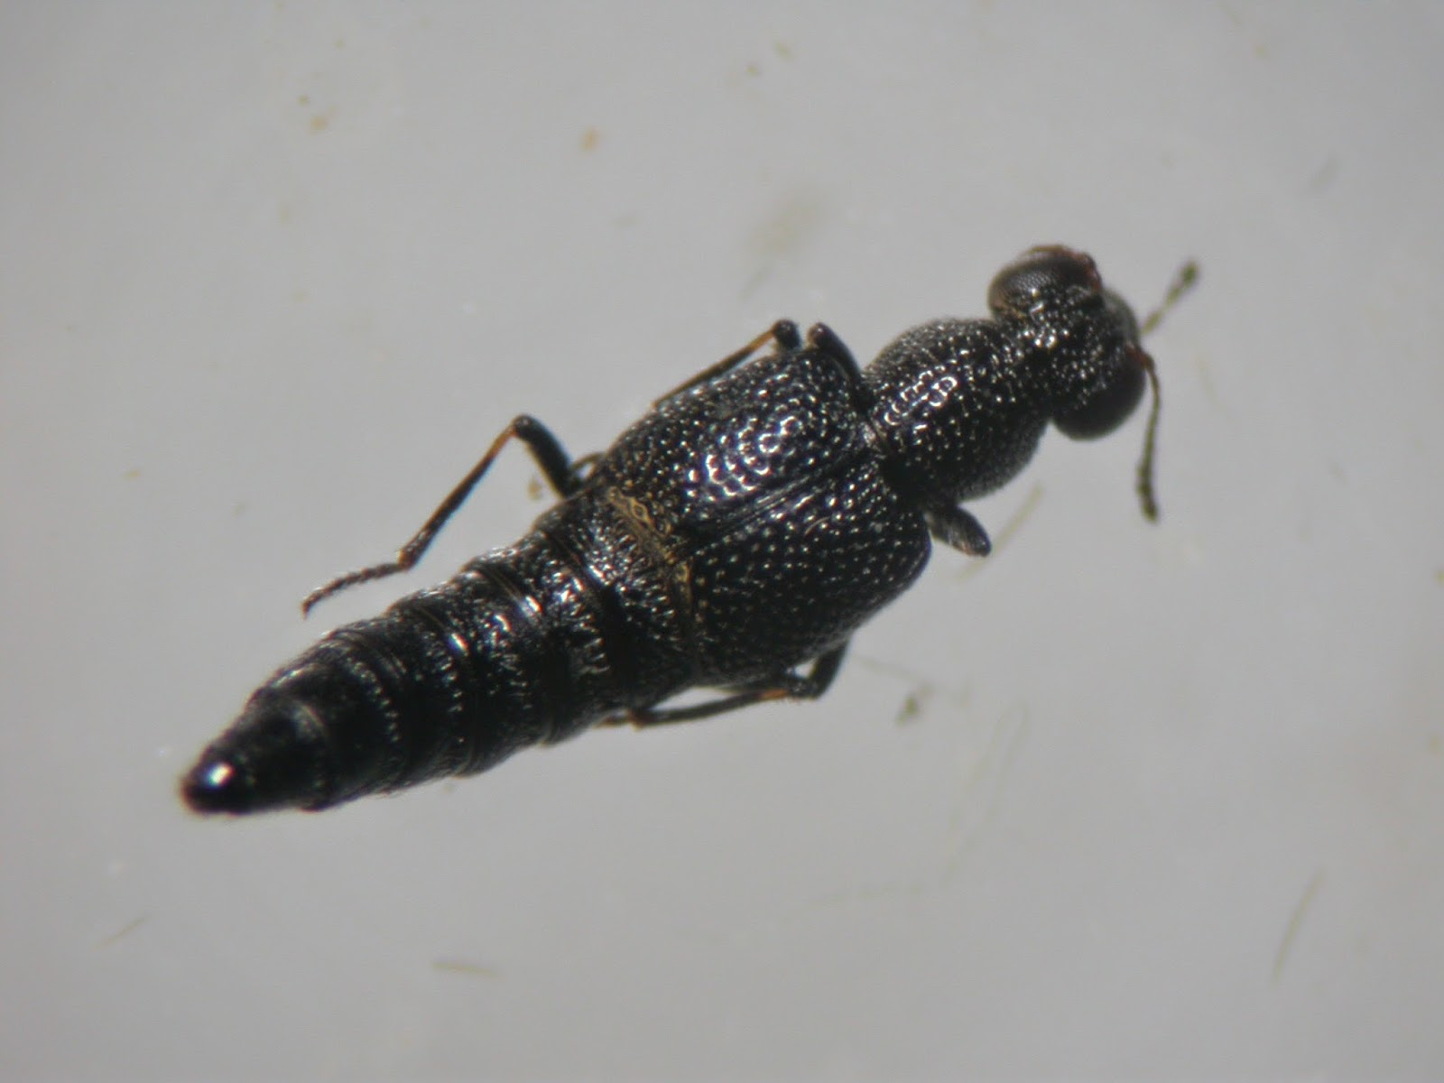

**Fig. 8.** *Stenus fornicatus*

This is a rove beetle in a genus of some 80 species. This one in particular is very small but has a highly distinctive ‘dumpy’ body shape. One was recorded from pond 4. The author has recorded this species in ditches on Pevensey Levels too.

* *Calomotropha paludella* – Nb

A medium sized greyish micro moth that feeds on reedmace.

* Reed Dagger – Nb

The larvae of this moth were found on all five ponds by sweeping.

* *Cassida nobilis* – Nb

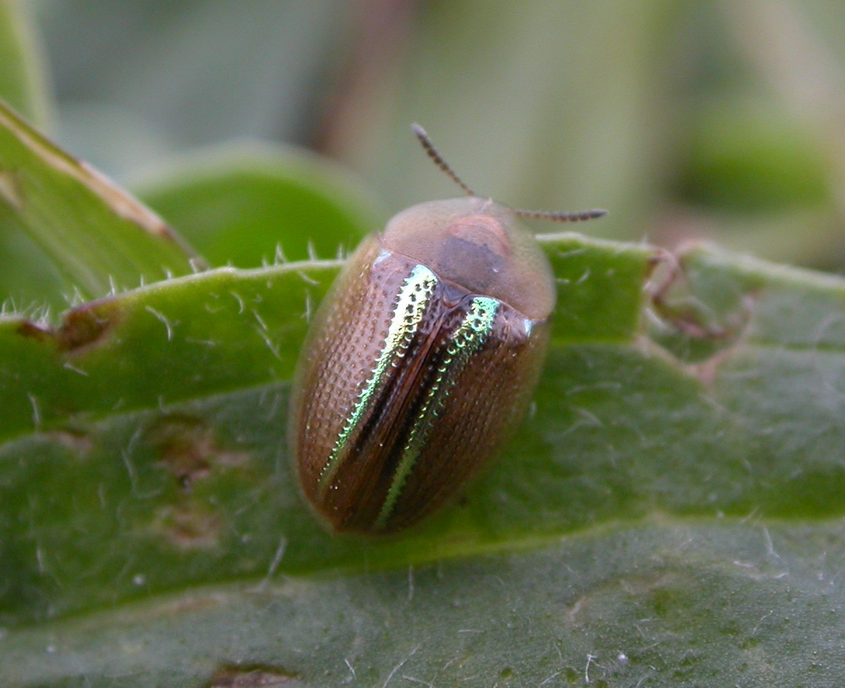

**Fig. 9.** The striking tortoise beetle *Cassida nobilis* (stock photo).

A single specimen of this impressive species with metallic gold parallel lines was swept from fen on the edge of pond 3 during July.

* *Rhantus frontalis* – Nationally scarce

This water beetle was recorded from ponds 0, 2 & 3 in September.

* *Peltodytes caesus* – Nationally scarce

Another water beetle recorded from Pond 2 only in May and September. The author has recorded this species from Pevensey Levels.

* Black Colonel *Odontomyia tigrina* – Nationally Scarce

A non-descript black solider fly recorded on the edges of Ponds 1 and 3 during the May visit only.

**3.3 – Analysis of the five ponds**

**3.3.1 – Total number of species recorded**



**Fig. 10.** Pond 3 was the only pond to record more than half of all the species recorded across the whole site.

**3.3.2 – Proportion of rare and scarce invertebrates**



**Fig. 11.** Ponds 1, 2 and 3 show a greater proportion of rare and scarce species than all the ponds combined.

**3.3.3 – ‘Community Conservation Score’**

An index system was put together in 2004 by Chadd & Extence. For almost all species of UK macro invertabrate, a score from 1 to 10 was given whereby 1 was assigned to the most common species and 10 reserved for the rarest species. The largest Conservation Scores (CSs) for species recorded at Patchurst were for the small water beetle ***Hydrochus elongatus*** (CS=8) and the **Lesser Water-measurer *Hydrometra gracilenta*** (CS=8). The rarest species of the survey, the Pondweed Leafhopper is not listed as having a CS score. This is perhaps an oversight but it may also be because no hoppers are included in Chadd & Extence. If it had been included the author suggests its CS score should be 9.

The Community Conservation Index (CCI) is calculated by the sum of all the Conservation Scores in any given water body divided by the number of contributing species. It is then multiplied by the greatest CS present in that water body. For Patchurst Marsh as a whole, 94 species qualified as having Conservation Scores (94 truly aquatic invertebrates essentially).

The CCI for the five ponds and the five ponds collectively is given below.



**Fig. 12.** Showing the CCIs for each pond as well as the total number of contributing species.

Chadd & Extence state that a CCI score of:

>15.0 to 20.0 – sites supporting several uncommon species, at least one of which may be nationally rare and/or a community of high taxon richness. High conservation value.

Individually, Pond 1 was the only pond to fall just into this category with a CCI of 19.4.

>20.0 – sites supporting several rarities , including species of national importance, or at least one of extreme rarity (e.g. taxa included in the British RDBs) and/or a community of very high taxon richness. Very high conservation value (potentially of national significance and may merit statutory protection).

Individually all other ponds and the whole site all fall into this category. A collective CCI of 34.4 is the real important value in this exercise, the comparison between the ponds is for interest only. That said, Ponds 2 & 4 came out the highest, considerably more than the other ponds. This might have simply been due to there being more opportunities to net water beetles. If you also look at the proportion of rare and scarce species of all invertebrates (not just aquatics), Ponds 2 & 4 again come out the highest, suggesting they are genuinely better than the other ponds. This could be due to a more varied structure in places. This does however not tally with observations made in the field. If anything the author would have thought Ponds 1 & 3 appeared the most variable in micro-habitats.

**3.4 - Records**

A total of 676 records were made during the survey and are attached in the appendices. The records have also been submitted to the Sussex Biological Records centre.

**4 – Conclusions**

Individually the ponds at Patchurst Marsh could be considered nationally significant for their aquatic invertebrates but collectively they have an even greater conservation value. A big reason for this is the proximity to the Pevensey Levels SSSI which itself has an exceptional invertebrate fauna. In addition, the ponds are relatively new so some of the rare species associated with early successional habitats may also be contributing to the quality of the fauna.

Ponds 2 and 4 seem to have a greater number of rare and scarce invertebrates associated with them but it is not clear why this is the case.

Beyond the aquatics there is also an interesting fauna associated with emergent plants and the meadow fauna between the ponds. Small tweaks to the management of the ponds and the areas in-between could not only help maintain but maximise the invertebrate and biodiversity value of the sites.

The fantastic wildlife haven created by David & Marian Harding should be celebrated and is a brilliant example of what can be done for wildlife by private land owners. The rare and unusual invertebrates that have colonised the area tell a fantastic story.

**5 – Management recommendations**

**5.1 - Principals of habitat management for invertebrates**

In terms of invertebrates, it’s really important to think a little differently when managing sites for nature conservation. Several key principles need to be addressed and these really come from one major point and this is that most invertebrates have one year life cycles, if those conditions are not met, local extinctions can occur. Fortunately many of them are good disperses and recolonise but many of them are not. It is therefore better to allow some examples of good habitat for as many species as possible in every year. This therefore means maximising diversity of micro habitats in every year. This can be achieved by adopting the following principles:

* Never do everything all at once.

Where possible, cut the grass in a staggered approach over a number of weeks. Cut a proportion of reed on a long term cycle etc.

* Never do everything exactly the same year after year.

Repeating management identically favours a small number of species at the expense of many. It’s better to tweak the small variables such as time of year, size of area cut, number of livestock, time livestock are deployed etc. This way provides greater structural diversity over a long time without deviating greatly from the overall approach.

* Think micro habitats.

Almost every micro-habitat you can think of will have species that exploit it. Therefore greater diversity of micro habitats will support a greater diversity of wildlife.

* Remove the majority of arisings where ever possible.

Nutrient build up from litter and arisings over time encourages the growth of course grasses at the expense of more floribund communities. On small sites this affect may not be seen for many years but can become a significant problem over time.

* Maximise edge habitats (length and thickness).

The gradual transition from one habitat to another is likely to support many interesting species. Maximising this resource is of great benefit to wildlife.

**5.2 - Specific habitat management recommendations**

* Allow some willow to grow

Although willow is incredibly invasive, it is definitely worth having some on the site. There are many species that will feed directly on the willow itself but also that will benefit from the variety of structure and the shelter that it provides. If one or two bushes per pond were left to grow up a bit, they could always be cut down before getting too big whereby they could be replaced by the next ones in a successional cycle.

* Winter cutting of reed promotes reed

Long term and without any management, reedbeds accumulate litter over time as all the previous year’s dead stems collapse and build up a dense layer. This can dry out the reedbed long term whereby nettles can start to take hold and change the nature of the reedbed. As much of the site can still be considered ‘pioneer’ reed, this is a long way off at Patchurst Marsh but some management should be put in order to maintain a proportion of the site as pioneer reedbed habitat. As with all things, many invertebrate species will also benefit from the dense litter layer so it’s a balancing act. It’s usually the early successional and late successional habitats that suffer so a proportion of the reedbed should always fall into these two categories. Cutting in the winter, which might be difficult without water level control, is the way to maintain some early successional reedbed and maintain the dominance of reed. Arisings should be removed/burnt where possible but some small piles of reed litter would not be too harmful for the site, this would need to be managed though in such a relatively small site.

* Summer cutting of fen area promotes fen vegetation

In order to reduce the vigour of reed and promote fenland plants, nectar sources and general diversity, summer cutting (August-September) and removal of arisings will greatly help. Ares where this could be carried out include the north western edge of pond 3. This is currently very rich and a great nectar source but reed could easily encroach here and when/if it does, summer cutting should be carried out to maintain the fen.

* Mowing of grassland

The presence of the Long-horned Mining Bee is an indicator of the quality of the grassland between the ponds. However, the whole of the area between the ponds (right up to and including the edge of the fen habitat) was cut at the same time between two visits. It is clear that the current mowing regime benefits the grassland in the spring and early summer, as it was full of clovers and flowers but cutting all of it at once is really poor for invertebrates. It would be best to cut only a proportion of the grassland and leave some soft edges or ecotones up to the edges of the ponds. This could be done on a rotation. Cuttings should be removed where possible.

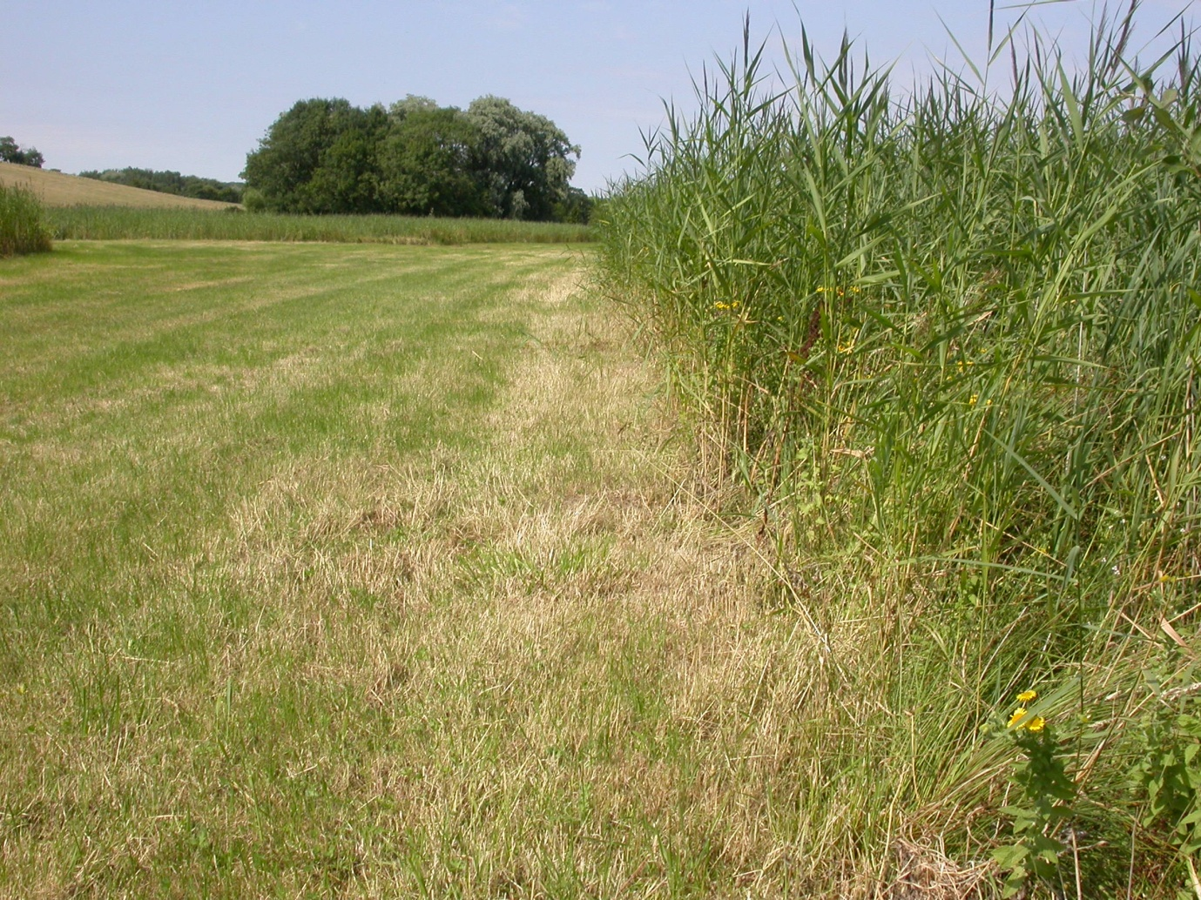

**Fig. 13.** A bad ecotone.

* Cutting edge of ponds and dumping material there.

The ecotone was further damaged this summer by leaving the cut material in place, thereby preventing a nice floristic ecotone developing there in the future. If these areas are to be cut in the summer they should be done deliberately, only a fraction in any one year and the cut material removed from the margins.

* Mowing vs. Grazing

Light summer cattle grazing could be used as an alternative/variation/addition to the summer cut.. As every year is different and the last few years particularly have seen an incredible summer growth of plants such as Yorkshire Fog, it’s important to be reactive and to not do exactly the same thing year after year. Pouching is a vital component of this habitat but having some areas that are short into late summer is also of great benefit to invertebrates.

**5.2 – Future monitoring**

This intensity of surveying is perhaps only worth repeating on a ten year cycle. One way of seeing if larger water beetles are present but have been missed by this particular survey method would be to place bottle traps over night with bait (such as bacon). These traps can be incredibly succesful and may be more successful at collecting the larger beetles. The authour would be happy to come and do this at some point for interest.

**References and bibliography**

|  |
| --- |
| **Chadd, R. & Extence, C.** (2004) *The conservation of freshwater macroinvertebrate populations: a community-based classification scheme*. Aquatic Conserv: Mar. Freshw. Ecosyst. 14: 597-624.  **Cox, M.** (2007) *Atlas of the Seed and Leaf Beetles of Britain and Ireland*. Pisces Publications.  **Duff, A.** (2012) Beetles of Britain and Ireland volume 1: Sphaeriusidae to Silphidae. West Runton, Norfolk. |
| **Duff, A. G.** (2012) Checklist of the Beetles of the British Isles, 2nd edition. Pemberley Books. |
|  |
| **Levey, B.** (2010) British Scraptidae. Royal Entomological Society |
| **Lott. D. A. & Anderson, R. (**2011) The Staphylinidae (rove beetles) of Britain and Ireland Parts 7 & Oxyporinae, Steninae, Euaesthetinae, Pseudopsainae, Paederinae, Staphylininae. Royal Entomological Society. |
| **Luff, M. L.** (2007) The Carabidae (ground beetles) of Britain and Ireland. Royal Entomological Society. |
|  |
| **Pontin, J.** (2005) Ants of Surrey. Surrey Wildlife Trust. |
| **Porter, J.** (1997) The Colour Identification Guide to Caterpillars of the British Isles. |
| **Roberts, M. J.** (1995) Field Guide to Spiders of Britain and Europe. Collins  http://www.freshwaterhabitats.org.uk/wordpress/wp-content/uploads/2013/09/Pondweed-Leafhopper-new-logo.pdf last accessed 13/01/2015. |

**Acknowledgements**

A big thank you to David and Marian Harding for commissioning the survey. Also a big thank you to Mark Telfer, Alan Stewart, Oliver Froom, Niall Basquille and Seth Gibson for helping out on some of the field visits. Thanks also to Francesca Dunn for providing an excellent paper on assessing pond quality through invertebrate assemblages.

**Appendices**

The rolling spreadsheet that formed the basis of this survey has been provided in an associated Excel file. Here the records which were submitted to the Sussex Biodiversity Records Centre have been provided.

|  |  |  |  |  |  |
| --- | --- | --- | --- | --- | --- |
| crustacean | Asellus aquaticus | Present Count of Adult | Patchurst - Pond 0 | 19/04/2014 | netted |
| crustacean | Asellus aquaticus | Present Count of Adult | Patchurst - Pond 2 | 19/04/2014 | netted |
| crustacean | Asellus aquaticus | Present Count of Adult | Patchurst - Pond 3 | 19/04/2014 | netted |
| crustacean | Crangonyx pseudogracilis | Present Count of Taxon | Patchurst - Pond 0 | 19/04/2014 | netted |
| crustacean | Crangonyx pseudogracilis | Present Count of Adult | Patchurst - Pond 1 | 19/04/2014 | netted |
| crustacean | Crangonyx pseudogracilis | Present Count of Adult | Patchurst - Pond 3 | 19/04/2014 | netted |
| crustacean | Oniscus asellus | 1 Count of Adult | Patchurst - Pond 1 | 19/04/2014 | sieved |
| crustacean | Oniscus asellus | 1 Count of Adult | Patchurst - Pond 3 | 29/07/2014 | swept |
| crustacean | Philoscia muscorum | Present Count of Adult | Patchurst - Pond 1 | 19/04/2014 | sieved |
| crustacean | Philoscia muscorum | 1 Count of Adult | Patchurst - Pond 3 | 29/07/2014 | swept |
| flatworm (Turbellaria) | Polycelis nigra | 1 Count of Adult | Patchurst - Pond 1 | 19/04/2014 | netted |
| harvestman (Opiliones) | Platybunus triangularis | 2 Count of present | Patchurst - Pond 1 | 19/04/2014 | microscopically examined |
| harvestman (Opiliones) | Platybunus triangularis | 1 Count of Adult | Patchurst - Pond 4 | 19/04/2014 | microscopically examined |
| insect - alderfly (Megaloptera) | Sialis lutaria | 1 Count of Adult | Patchurst - Pond 0 | 18/05/2014 | Genitalia examined |
| insect - alderfly (Megaloptera) | Sialis lutaria | 1 Count of Adult Male | Patchurst - Pond 1 | 19/04/2014 | Genitalia examined |
| insect - alderfly (Megaloptera) | Sialis lutaria | 2 Count of Adult Male | Patchurst - Pond 4 | 19/04/2014 | Genitalia examined |
| insect - beetle (Coleoptera) | Abax parallelepipedus | 1 Count of Adult | Patchurst - Pond 0 | 21/06/2014 | None |
| insect - beetle (Coleoptera) | Acupalpus dubius | 1 Count of Adult | Patchurst - Pond 3 | 19/04/2014 | microscopically examined |
| insect - beetle (Coleoptera) | Acupalpus parvulus | 1 Count of Adult | Patchurst - Pond 0 | 19/04/2014 | microscopically examined |
| insect - beetle (Coleoptera) | Adalia decempunctata | 1 Count of Adult | Patchurst - Pond 2 | 21/06/2014 | swept |
| insect - beetle (Coleoptera) | Agabus (Acatodes) sturmii | 1 Count of Adult | Patchurst - Pond 0 | 28/09/2014 | microscopically examined |
| insect - beetle (Coleoptera) | Agabus (Acatodes) sturmii | 1 Count of Adult | Patchurst - Pond 1 | 20/08/2014 | netted |
| insect - beetle (Coleoptera) | Agabus (Acatodes) sturmii | 1 Count of Adult | Patchurst - Pond 3 | 19/04/2014 | netted |
| insect - beetle (Coleoptera) | Agabus (Gaurodytes) bipustulatus | 1 Count of Adult | Patchurst - Pond 0 | 28/09/2014 | microscopically examined |
| insect - beetle (Coleoptera) | Agabus (Gaurodytes) bipustulatus | 1 Count of Adult | Patchurst - Pond 1 | 18/05/2014 | microscopically examined |
| insect - beetle (Coleoptera) | Agabus (Gaurodytes) bipustulatus | 1 Count of Adult | Patchurst - Pond 2 | 28/09/2014 | microscopically examined |
| insect - beetle (Coleoptera) | Agabus (Gaurodytes) bipustulatus | 1 Count of Adult | Patchurst - Pond 3 | 28/09/2014 | microscopically examined |
| insect - beetle (Coleoptera) | Agabus (Gaurodytes) bipustulatus | 1 Count of Adult | Patchurst - Pond 4 | 28/09/2014 | microscopically examined |
| insect - beetle (Coleoptera) | Agabus (Gaurodytes) nebulosus | 1 Count of Adult | Patchurst - Pond 0 | 18/05/2014 | microscopically examined |
| insect - beetle (Coleoptera) | Agabus (Gaurodytes) nebulosus | 1 Count of Adult | Patchurst - Pond 4 | 29/07/2014 | netted |
| insect - beetle (Coleoptera) | Agonum (Europhilus) fuliginosum | 1 Count of Adult | Patchurst - Pond 0 | 19/04/2014 | microscopically examined |
| insect - beetle (Coleoptera) | Agonum (Europhilus) fuliginosum | 1 Count of Adult | Patchurst - Pond 3 | 19/04/2014 | microscopically examined |
| insect - beetle (Coleoptera) | Agonum (Europhilus) thoreyi | 1 Count of Adult | Patchurst - Pond 0 | 19/04/2014 | microscopically examined |
| insect - beetle (Coleoptera) | Agonum (Europhilus) thoreyi | 3 Count of Adult | Patchurst - Pond 1 | 19/04/2014 | sieved |
| insect - beetle (Coleoptera) | Agonum (Europhilus) thoreyi | 1 Count of Adult | Patchurst - Pond 2 | 18/05/2014 | microscopically examined |
| insect - beetle (Coleoptera) | Agonum (Europhilus) thoreyi | 1 Count of Adult | Patchurst - Pond 4 | 29/07/2014 | microscopically examined |
| insect - beetle (Coleoptera) | Agriotes lineatus | Present Count of Adult | Patchurst - Pond 1 | 18/05/2014 | sieved |
| insect - beetle (Coleoptera) | Agriotes lineatus | 2 Count of Adult | Patchurst - Pond 2 | 18/05/2014 | sieved |
| insect - beetle (Coleoptera) | Agriotes lineatus | Present Count of Adult | Patchurst - Pond 3 | 18/05/2014 | sieved |
| insect - beetle (Coleoptera) | Altica palustris | 1 Count of Adult Male | Patchurst - Pond 1 | 19/04/2014 | Genitalia examined |
| insect - beetle (Coleoptera) | Anacaena limbata | 1 Count of Adult | Patchurst - Pond 0 | 19/04/2014 | microscopically examined |
| insect - beetle (Coleoptera) | Anacaena limbata | 1 Count of Adult | Patchurst - Pond 1 | 19/04/2014 | microscopically examined |
| insect - beetle (Coleoptera) | Anacaena limbata | 3 Count of Adult | Patchurst - Pond 3 | 19/04/2014 | microscopically examined |
| insect - beetle (Coleoptera) | Anisosticta novemdecimpunctata | Present Count of Adult | Patchurst - Pond 0 | 18/05/2014 | swept |
| insect - beetle (Coleoptera) | Anisosticta novemdecimpunctata | 1 Count of Adult | Patchurst - Pond 1 | 19/04/2014 | swept |
| insect - beetle (Coleoptera) | Anisosticta novemdecimpunctata | 1 Count of Adult | Patchurst - Pond 2 | 19/04/2014 | swept |
| insect - beetle (Coleoptera) | Anisosticta novemdecimpunctata | 1 Count of Adult | Patchurst - Pond 3 | 19/04/2014 | swept |
| insect - beetle (Coleoptera) | Anisosticta novemdecimpunctata | Present Count of Adult | Patchurst - Pond 4 | 18/05/2014 | None |
| insect - beetle (Coleoptera) | Anthocomus rufus | Present Count of Adult | Patchurst - Pond 0 | 29/07/2014 | swept |
| insect - beetle (Coleoptera) | Anthocomus rufus | Present Count of Adult | Patchurst - Pond 1 | 29/07/2014 | swept |
| insect - beetle (Coleoptera) | Anthocomus rufus | Present Count of Adult | Patchurst - Pond 2 | 29/07/2014 | swept |
| insect - beetle (Coleoptera) | Anthocomus rufus | Present Count of Adult | Patchurst - Pond 3 | 29/07/2014 | swept |
| insect - beetle (Coleoptera) | Anthocomus rufus | Present Count of Adult | Patchurst - Pond 4 | 29/07/2014 | swept |
| insect - beetle (Coleoptera) | Aphodius (Agrilinus) constans | 1 Count of Adult | Patchurst - Pond 1 | 19/04/2014 | microscopically examined |
| insect - beetle (Coleoptera) | Aphodius (Melinopterus) sphacelatus | 1 Count of Adult | Patchurst - Pond 1 | 19/04/2014 | microscopically examined |
| insect - beetle (Coleoptera) | Apion frumentarium | 1 Count of Adult | Patchurst - Pond 1 | 20/08/2014 | microscopically examined |
| insect - beetle (Coleoptera) | Astenus (Astenus) immaculatus | 1 Count of Adult | Patchurst - Pond 4 | 28/09/2014 | microscopically examined |
| insect - beetle (Coleoptera) | Badister (Badister) bullatus | 1 Count of Adult | Patchurst - Pond 4 | 18/05/2014 | microscopically examined |
| insect - beetle (Coleoptera) | Bembidion (Nepha) illigeri | Present Count of Adult | Patchurst - Pond 3 | 18/05/2014 | None |
| insect - beetle (Coleoptera) | Bembidion (Philochthus) biguttatum | 1 Count of Adult | Patchurst - Pond 3 | 19/04/2014 | microscopically examined |
| insect - beetle (Coleoptera) | Bembidion (Trepanes) articulatum | 1 Count of Adult | Patchurst - Pond 0 | 29/07/2014 | microscopically examined |
| insect - beetle (Coleoptera) | Bembidion (Trepanes) articulatum | 1 Count of Adult | Patchurst - Pond 3 | 21/06/2014 | microscopically examined |
| insect - beetle (Coleoptera) | Berosus (Berosus) affinis | 2 Count of Adult | Patchurst - Pond 0 | 29/07/2014 | swept |
| insect - beetle (Coleoptera) | Bruchidius varius | 1 Count of Adult | Patchurst - Pond 1 | 29/07/2014 | microscopically examined |
| insect - beetle (Coleoptera) | Bruchidius varius | 1 Count of Adult | Patchurst - Pond 3 | 29/07/2014 | microscopically examined |
| insect - beetle (Coleoptera) | Cantharis cryptica | 1 Count of Adult | Patchurst - Pond 0 | 21/06/2014 | microscopically examined |
| insect - beetle (Coleoptera) | Cantharis lateralis | 1 Count of Adult | Patchurst - Pond 1 | 21/06/2014 | swept |
| insect - beetle (Coleoptera) | Cantharis lateralis | Present Count of Adult | Patchurst - Pond 2 | 21/06/2014 | swept |
| insect - beetle (Coleoptera) | Cantharis nigra | Present Count of Adult | Patchurst - Pond 1 | 21/06/2014 | swept |
| insect - beetle (Coleoptera) | Cantharis nigra | Present Count of Adult | Patchurst - Pond 2 | 21/06/2014 | None |
| insect - beetle (Coleoptera) | Cantharis nigra | Present Count of Adult | Patchurst - Pond 4 | 21/06/2014 | None |
| insect - beetle (Coleoptera) | Cartodere (Aridius) nodifer | 1 Count of Adult | Patchurst - Pond 3 | 28/09/2014 | None |
| insect - beetle (Coleoptera) | Cassida nobilis | 1 Count of Adult | Patchurst - Pond 3 | 20/08/2014 | microscopically examined |
| insect - beetle (Coleoptera) | Cassida rubiginosa | 2 Count of Adult | Patchurst - Pond 1 | 19/04/2014 | swept |
| insect - beetle (Coleoptera) | Cassida rubiginosa | 1 Count of Adult | Patchurst - Pond 3 | 18/05/2014 | microscopically examined |
| insect - beetle (Coleoptera) | Cassida rubiginosa | Present Count of Adult | Patchurst - Pond 4 | 29/07/2014 | swept |
| insect - beetle (Coleoptera) | Chilocorus renipustulatus | 1 Count of Adult | Patchurst - Pond 0 | 29/07/2014 | swept |
| insect - beetle (Coleoptera) | Chrysolina polita | 1 Count of Adult | Patchurst - Pond 3 | 18/05/2014 | None |
| insect - beetle (Coleoptera) | Coccidula rufa | Present Count of Adult | Patchurst - Pond 0 | 19/04/2014 | swept |
| insect - beetle (Coleoptera) | Coccidula rufa | 1 Count of Adult | Patchurst - Pond 1 | 19/04/2014 | swept |
| insect - beetle (Coleoptera) | Coccidula rufa | 1 Count of Adult | Patchurst - Pond 2 | 29/07/2014 | swept |
| insect - beetle (Coleoptera) | Coccidula rufa | 1 Count of Adult | Patchurst - Pond 3 | 18/05/2014 | None |
| insect - beetle (Coleoptera) | Coccidula scutellata | 1 Count of Adult | Patchurst - Pond 1 | 20/08/2014 | swept |
| insect - beetle (Coleoptera) | Coccidula scutellata | 2 Count of Adult | Patchurst - Pond 2 | 20/08/2014 | swept |
| insect - beetle (Coleoptera) | Coccidula scutellata | 1 Count of Adult | Patchurst - Pond 3 | 20/08/2014 | swept |
| insect - beetle (Coleoptera) | Coccinella septempunctata | 1 Count of Adult | Patchurst - Pond 0 | 18/05/2014 | swept |
| insect - beetle (Coleoptera) | Coccinella septempunctata | 1 Count of Adult | Patchurst - Pond 1 | 29/07/2014 | swept |
| insect - beetle (Coleoptera) | Coccinella septempunctata | Present Count of Adult | Patchurst - Pond 2 | 18/05/2014 | None |
| insect - beetle (Coleoptera) | Colymbetes fuscus | 1 Count of Adult | Patchurst - Pond 0 | 28/09/2014 | microscopically examined |
| insect - beetle (Coleoptera) | Colymbetes fuscus | 1 Count of Adult | Patchurst - Pond 3 | 28/09/2014 | microscopically examined |
| insect - beetle (Coleoptera) | Crudosilis ruficollis | 1 Count of Adult | Patchurst - Pond 2 | 29/07/2014 | swept |
| insect - beetle (Coleoptera) | Cymbiodyta marginellus | 1 Count of Adult | Patchurst - Pond 0 | 19/04/2014 | microscopically examined |
| insect - beetle (Coleoptera) | Cymbiodyta marginellus | 1 Count of Adult | Patchurst - Pond 0 | 28/09/2014 | microscopically examined |
| insect - beetle (Coleoptera) | Demetrias (Demetrias) atricapillus | 1 Count of Adult | Patchurst - Pond 0 | 19/04/2014 | sieved |
| insect - beetle (Coleoptera) | Demetrias (Demetrias) atricapillus | 1 Count of Adult | Patchurst - Pond 1 | 19/04/2014 | sieved |
| insect - beetle (Coleoptera) | Demetrias (Demetrias) atricapillus | 1 Count of Adult | Patchurst - Pond 2 | 18/05/2014 | microscopically examined |
| insect - beetle (Coleoptera) | Demetrias (Demetrias) atricapillus | 1 Count of Adult | Patchurst - Pond 3 | 20/08/2014 | None |
| insect - beetle (Coleoptera) | Demetrias (Risophilus) imperialis | 1 Count of Adult | Patchurst - Pond 0 | 19/04/2014 | sieved |
| insect - beetle (Coleoptera) | Demetrias (Risophilus) imperialis | 1 Count of Adult | Patchurst - Pond 1 | 19/04/2014 | sieved |
| insect - beetle (Coleoptera) | Demetrias (Risophilus) imperialis | 1 Count of Adult | Patchurst - Pond 4 | 21/06/2014 | swept |
| insect - beetle (Coleoptera) | Donacia clavipes | 3 Count of Adult | Patchurst - Pond 2 | 20/08/2014 | None |
| insect - beetle (Coleoptera) | Donacia clavipes | 1 Count of Adult | Patchurst - Pond 4 | 21/06/2014 | swept |
| insect - beetle (Coleoptera) | Donacia marginata | 1 Count of Adult | Patchurst - Pond 2 | 18/05/2014 | microscopically examined |
| insect - beetle (Coleoptera) | Donacia marginata | 1 Count of Adult | Patchurst - Pond 3 | 21/06/2014 | microscopically examined |
| insect - beetle (Coleoptera) | Donacia semicuprea | 1 Count of Adult | Patchurst - Pond 1 | 18/05/2014 | microscopically examined |
| insect - beetle (Coleoptera) | Donacia thalassina | 1 Count of Adult | Patchurst - Pond 2 | 18/05/2014 | microscopically examined |
| insect - beetle (Coleoptera) | Donacia thalassina | 1 Count of Adult | Patchurst - Pond 4 | 18/05/2014 | microscopically examined |
| insect - beetle (Coleoptera) | Donacia versicolorea | 1 Count of Adult | Patchurst - Pond 2 | 21/06/2014 | swept |
| insect - beetle (Coleoptera) | Donacia versicolorea | 1 Count of Adult | Patchurst - Pond 4 | 21/06/2014 | microscopically examined |
| insect - beetle (Coleoptera) | Donacia vulgaris | 1 Count of Adult | Patchurst - Pond 0 | 18/05/2014 | swept |
| insect - beetle (Coleoptera) | Donacia vulgaris | 1 Count of Adult | Patchurst - Pond 3 | 21/06/2014 | microscopically examined |
| insect - beetle (Coleoptera) | Donacia vulgaris | 1 Count of Adult | Patchurst - Pond 4 | 21/06/2014 | microscopically examined |
| insect - beetle (Coleoptera) | Dytiscus marginalis | 1 Count of Adult Male | Patchurst - Pond 4 | 18/05/2014 | None |
| insect - beetle (Coleoptera) | Dytiscus marginalis | 1 Count of Adult Female | Patchurst - Pond 4 | 28/09/2014 | netted |
| insect - beetle (Coleoptera) | Elaphrus (Trichelaphrus) riparius | 2 Count of Adult | Patchurst - Pond 3 | 18/05/2014 | None |
| insect - beetle (Coleoptera) | Elaphrus (Trichelaphrus) riparius | 1 Count of Adult | Patchurst - Pond 3 | 21/06/2014 | microscopically examined |
| insect - beetle (Coleoptera) | Enochrus coarctatus | 1 Count of Adult | Patchurst - Pond 0 | 29/07/2014 | netted |
| insect - beetle (Coleoptera) | Enochrus coarctatus | 1 Count of Adult | Patchurst - Pond 3 | 18/05/2014 | microscopically examined |
| insect - beetle (Coleoptera) | Enochrus coarctatus | 1 Count of Adult | Patchurst - Pond 3 | 29/07/2014 | microscopically examined |
| insect - beetle (Coleoptera) | Enochrus melanocephalus | 1 Count of Adult | Patchurst - Pond 1 | 21/06/2014 | microscopically examined |
| insect - beetle (Coleoptera) | Enochrus melanocephalus | 1 Count of Adult | Patchurst - Pond 4 | 18/05/2014 | microscopically examined |
| insect - beetle (Coleoptera) | Enochrus testaceus | 1 Count of Adult | Patchurst - Pond 1 | 20/08/2014 | microscopically examined |
| insect - beetle (Coleoptera) | Enochrus testaceus | 1 Count of Adult | Patchurst - Pond 2 | 19/04/2014 | microscopically examined |
| insect - beetle (Coleoptera) | Enochrus testaceus | 1 Count of Adult | Patchurst - Pond 2 | 19/04/2014 | microscopically examined |
| insect - beetle (Coleoptera) | Enochrus testaceus | 1 Count of Adult | Patchurst - Pond 3 | 29/07/2014 | microscopically examined |
| insect - beetle (Coleoptera) | Enochrus testaceus | 1 Count of Adult | Patchurst - Pond 4 | 29/07/2014 | microscopically examined |
| insect - beetle (Coleoptera) | Erichsonius cinerascens | 1 Count of Adult | Patchurst - Pond 4 | 18/05/2014 | microscopically examined |
| insect - beetle (Coleoptera) | Galerucella lineola | 1 Count of Adult | Patchurst - Pond 3 | 21/06/2014 | microscopically examined |
| insect - beetle (Coleoptera) | Galerucella sagittariae | 1 Count of Adult | Patchurst - Pond 0 | 29/07/2014 | microscopically examined |
| insect - beetle (Coleoptera) | Galerucella sagittariae | 1 Count of Adult | Patchurst - Pond 1 | 19/04/2014 | microscopically examined |
| insect - beetle (Coleoptera) | Galerucella sagittariae | 1 Count of Adult | Patchurst - Pond 2 | 29/07/2014 | microscopically examined |
| insect - beetle (Coleoptera) | Gastrophysa polygoni | 1 Count of Adult | Patchurst - Pond 1 | 18/05/2014 | None |
| insect - beetle (Coleoptera) | Gastrophysa polygoni | 1 Count of Adult | Patchurst - Pond 3 | 19/04/2014 | swept |
| insect - beetle (Coleoptera) | Gastrophysa polygoni | 1 Count of Adult | Patchurst - Pond 4 | 19/04/2014 | swept |
| insect - beetle (Coleoptera) | Gyrinus caspius | 1 Count of Adult Male | Patchurst - Pond 3 | 28/09/2014 | Genitalia examined |
| insect - beetle (Coleoptera) | Gyrinus marinus | 1 Count of Adult Male | Patchurst - Pond 2 | 19/04/2014 | Genitalia examined |
| insect - beetle (Coleoptera) | Gyrinus marinus | 1 Count of Adult Male | Patchurst - Pond 3 | 28/09/2014 | Genitalia examined |
| insect - beetle (Coleoptera) | Gyrinus marinus | 1 Count of Adult Male | Patchurst - Pond 4 | 19/04/2014 | Genitalia examined |
| insect - beetle (Coleoptera) | Gyrinus paykulli | 1 Count of Adult Male | Patchurst - Pond 4 | 28/09/2014 | Genitalia examined |
| insect - beetle (Coleoptera) | Gyrohypnus fracticornis | 1 Count of Adult | Patchurst - Pond 4 | 28/09/2014 | microscopically examined |
| insect - beetle (Coleoptera) | Haliplus (Haliplinus) ruficollis | 1 Count of Adult Male | Patchurst - Pond 1 | 19/04/2014 | Genitalia examined |
| insect - beetle (Coleoptera) | Haliplus (Haliplinus) ruficollis | 1 Count of Adult Male | Patchurst - Pond 2 | 19/04/2014 | Genitalia examined |
| insect - beetle (Coleoptera) | Harmonia axyridis | 1 Count of Adult | Patchurst - Pond 0 | 18/05/2014 | swept |
| insect - beetle (Coleoptera) | Harmonia axyridis | 1 Count of Adult | Patchurst - Pond 1 | 28/09/2014 | None |
| insect - beetle (Coleoptera) | Harmonia axyridis | 1 Count of Adult | Patchurst - Pond 2 | 29/07/2014 | swept |
| insect - beetle (Coleoptera) | Harmonia axyridis | 1 Count of Adult | Patchurst - Pond 4 | 21/06/2014 | swept |
| insect - beetle (Coleoptera) | Helochares lividus | 1 Count of Adult | Patchurst - Pond 0 | 18/05/2014 | microscopically examined |
| insect - beetle (Coleoptera) | Helochares lividus | 1 Count of Adult | Patchurst - Pond 3 | 18/05/2014 | microscopically examined |
| insect - beetle (Coleoptera) | Helophorus (Atracthelophorus) brevipalpis | 1 Count of Adult | Patchurst - Pond 1 | 21/06/2014 | microscopically examined |
| insect - beetle (Coleoptera) | Helophorus (Helophorus) minutus | 1 Count of Adult | Patchurst - Pond 0 | 18/05/2014 | microscopically examined |
| insect - beetle (Coleoptera) | Helophorus (Helophorus) minutus | 1 Count of Adult | Patchurst - Pond 1 | 29/07/2014 | microscopically examined |
| insect - beetle (Coleoptera) | Helophorus (Helophorus) minutus | 1 Count of Adult | Patchurst - Pond 2 | 19/04/2014 | microscopically examined |
| insect - beetle (Coleoptera) | Helophorus (Helophorus) minutus | 1 Count of Adult | Patchurst - Pond 3 | 19/04/2014 | microscopically examined |
| insect - beetle (Coleoptera) | Helophorus (Helophorus) minutus | 1 Count of Adult | Patchurst - Pond 4 | 21/06/2014 | microscopically examined |
| insect - beetle (Coleoptera) | Helophorus (Helophorus) obscurus | 1 Count of Adult | Patchurst - Pond 3 | 19/04/2014 | microscopically examined |
| insect - beetle (Coleoptera) | Helophorus (Megahelophorus) grandis | 1 Count of Adult | Patchurst - Pond 0 | 19/04/2014 | microscopically examined |
| insect - beetle (Coleoptera) | Helophorus (Megahelophorus) grandis | 1 Count of Adult | Patchurst - Pond 3 | 19/04/2014 | microscopically examined |
| insect - beetle (Coleoptera) | Hippodamia (Hippodamia) tredecimpunctata | 1 Count of Adult | Patchurst - Pond 2 | 21/06/2014 | swept |
| insect - beetle (Coleoptera) | Hippodamia (Hippodamia) tredecimpunctata | 3 Count of Adult | Patchurst - Pond 2 | 29/07/2014 | swept |
| insect - beetle (Coleoptera) | Hydrobius fuscipes | 1 Count of Adult | Patchurst - Pond 0 | 29/07/2014 | netted |
| insect - beetle (Coleoptera) | Hydrobius fuscipes | 1 Count of Adult | Patchurst - Pond 2 | 21/06/2014 | microscopically examined |
| insect - beetle (Coleoptera) | Hydrobius fuscipes | 1 Count of Adult | Patchurst - Pond 3 | 29/07/2014 | netted |
| insect - beetle (Coleoptera) | Hydrobius fuscipes | 1 Count of Adult | Patchurst - Pond 4 | 29/07/2014 | microscopically examined |
| insect - beetle (Coleoptera) | Hydrochus elongatus | 1 Count of Adult | Patchurst - Pond 4 | 29/07/2014 | microscopically examined |
| insect - beetle (Coleoptera) | Hydroporus angustatus | 1 Count of Adult | Patchurst - Pond 0 | 18/05/2014 | microscopically examined |
| insect - beetle (Coleoptera) | Hydroporus planus | 1 Count of Adult | Patchurst - Pond 0 | 19/04/2014 | microscopically examined |
| insect - beetle (Coleoptera) | Hydroporus planus | 1 Count of Adult | Patchurst - Pond 1 | 19/04/2014 | microscopically examined |
| insect - beetle (Coleoptera) | Hydroporus planus | 1 Count of Adult | Patchurst - Pond 3 | 19/04/2014 | microscopically examined |
| insect - beetle (Coleoptera) | Hydroporus planus | 1 Count of Adult | Patchurst - Pond 4 | 18/05/2014 | microscopically examined |
| insect - beetle (Coleoptera) | Hydroporus pubescens | 1 Count of Adult | Patchurst - Pond 0 | 18/05/2014 | microscopically examined |
| insect - beetle (Coleoptera) | Hydroporus pubescens | 1 Count of Adult | Patchurst - Pond 4 | 28/09/2014 | microscopically examined |
| insect - beetle (Coleoptera) | Hydroporus tessellatus | 1 Count of Adult | Patchurst - Pond 0 | 19/04/2014 | microscopically examined |
| insect - beetle (Coleoptera) | Hydroporus tessellatus | 1 Count of Adult | Patchurst - Pond 1 | 19/04/2014 | microscopically examined |
| insect - beetle (Coleoptera) | Hydroporus tessellatus | 1 Count of Adult | Patchurst - Pond 3 | 19/04/2014 | microscopically examined |
| insect - beetle (Coleoptera) | Hygrobia hermanni | 1 Count of Adult | Patchurst - Pond 2 | 18/05/2014 | netted |
| insect - beetle (Coleoptera) | Hygrobia hermanni | 1 Count of Adult | Patchurst - Pond 4 | 28/09/2014 | netted |
| insect - beetle (Coleoptera) | Hygrotus (Coelambus) impressopunctatus | 1 Count of Adult | Patchurst - Pond 0 | 28/09/2014 | microscopically examined |
| insect - beetle (Coleoptera) | Hygrotus (Coelambus) impressopunctatus | 1 Count of Adult | Patchurst - Pond 2 | 28/09/2014 | microscopically examined |
| insect - beetle (Coleoptera) | Hygrotus (Coelambus) impressopunctatus | 1 Count of Adult | Patchurst - Pond 3 | 28/09/2014 | microscopically examined |
| insect - beetle (Coleoptera) | Hygrotus (Hygrotus) inaequalis | 1 Count of Adult | Patchurst - Pond 0 | 28/09/2014 | microscopically examined |
| insect - beetle (Coleoptera) | Hygrotus (Hygrotus) inaequalis | 1 Count of Adult | Patchurst - Pond 2 | 19/04/2014 | microscopically examined |
| insect - beetle (Coleoptera) | Hygrotus (Hygrotus) inaequalis | 1 Count of Adult | Patchurst - Pond 3 | 28/09/2014 | microscopically examined |
| insect - beetle (Coleoptera) | Hygrotus (Hygrotus) inaequalis | 1 Count of Adult | Patchurst - Pond 4 | 20/08/2014 | microscopically examined |
| insect - beetle (Coleoptera) | Hypera (Eririnomorphus) rumicis | 1 Count of Adult | Patchurst - Pond 1 | 21/06/2014 | microscopically examined |
| insect - beetle (Coleoptera) | Hypera (Hypera) plantaginis | 1 Count of Adult | Patchurst - Pond 2 | 29/07/2014 | microscopically examined |
| insect - beetle (Coleoptera) | Hyphydrus ovatus | 1 Count of Adult | Patchurst - Pond 3 | 28/09/2014 | netted |
| insect - beetle (Coleoptera) | Hyphydrus ovatus | 1 Count of Adult | Patchurst - Pond 4 | 29/07/2014 | swept |
| insect - beetle (Coleoptera) | Ilybius ater | 1 Count of Adult | Patchurst - Pond 1 | 18/05/2014 | microscopically examined |
| insect - beetle (Coleoptera) | Ischnodes sanguinicollis | 1 Count of Adult; 1 Count of Nymph | Patchurst - Pond 3 | 19/04/2014 | None |
| insect - beetle (Coleoptera) | Ischnopterapion (Ischnopterapion) modestum | 1 Count of Adult | Patchurst - Pond 3 | 21/06/2014 | microscopically examined |
| insect - beetle (Coleoptera) | Kateretes rufilabris | 1 Count of Adult | Patchurst - Pond 2 | 20/08/2014 | swept |
| insect - beetle (Coleoptera) | Laccobius bipunctatus | 2 Count of Adult | Patchurst - Pond 1 | 20/08/2014 | microscopically examined |
| insect - beetle (Coleoptera) | Laccophilus minutus | 1 Count of Adult | Patchurst - Pond 0 | 28/09/2014 | microscopically examined |
| insect - beetle (Coleoptera) | Lema cyanella | 1 Count of Adult | Patchurst - Pond 2 | 20/08/2014 | swept |
| insect - beetle (Coleoptera) | Leptura quadrifasciata | 1 Count of Adult | Patchurst - Pond 1 | 29/07/2014 | None |
| insect - beetle (Coleoptera) | Limnoxenus niger | 1 Count of Adult | Patchurst - Pond 2 | 20/08/2014 | netted |
| insect - beetle (Coleoptera) | Limnoxenus niger | 1 Count of Adult | Patchurst - Pond 3 | 20/08/2014 | netted |
| insect - beetle (Coleoptera) | Limnoxenus niger | 1 Count of Adult | Patchurst - Pond 4 | 29/07/2014 | microscopically examined |
| insect - beetle (Coleoptera) | Liophloeus tessulatus | 1 Count of Adult | Patchurst - Pond 2 | 19/04/2014 | swept |
| insect - beetle (Coleoptera) | Liopterus haemorrhoidalis | 1 Count of Adult | Patchurst - Pond 3 | 18/05/2014 | microscopically examined |
| insect - beetle (Coleoptera) | Loricera pilicornis | 1 Count of Adult | Patchurst - Pond 0 | 28/09/2014 | None |
| insect - beetle (Coleoptera) | Margarinotus (Paralister) neglectus | 1 Count of Adult Male | Patchurst - Pond 4 | 18/05/2014 | Genitalia examined |
| insect - beetle (Coleoptera) | Nedyus quadrimaculatus | 1 Count of Adult | Patchurst - Pond 0 | 18/05/2014 | swept |
| insect - beetle (Coleoptera) | Neophytobius quadrinodosus | 1 Count of Adult | Patchurst - Pond 0 | 18/05/2014 | microscopically examined |
| insect - beetle (Coleoptera) | Noterus clavicornis | 1 Count of Adult | Patchurst - Pond 1 | 19/04/2014 | netted |
| insect - beetle (Coleoptera) | Noterus clavicornis | 1 Count of Adult | Patchurst - Pond 2 | 19/04/2014 | netted |
| insect - beetle (Coleoptera) | Noterus clavicornis | Present Count of Adult | Patchurst - Pond 3 | 19/04/2014 | netted |
| insect - beetle (Coleoptera) | Noterus clavicornis | 1 Count of Adult | Patchurst - Pond 4 | 19/04/2014 | netted |
| insect - beetle (Coleoptera) | Ochthebius (Homalochthebius) minimus | 1 Count of Adult | Patchurst - Pond 0 | 28/09/2014 | microscopically examined |
| insect - beetle (Coleoptera) | Ochthebius (Homalochthebius) minimus | 1 Count of Adult | Patchurst - Pond 3 | 19/04/2014 | microscopically examined |
| insect - beetle (Coleoptera) | Odacantha melanura | 1 Count of Adult | Patchurst - Pond 0 | 20/08/2014 | None |
| insect - beetle (Coleoptera) | Odacantha melanura | 1 Count of Adult | Patchurst - Pond 1 | 19/04/2014 | sieved |
| insect - beetle (Coleoptera) | Odacantha melanura | 1 Count of Adult | Patchurst - Pond 2 | 18/05/2014 | None |
| insect - beetle (Coleoptera) | Odacantha melanura | 2 Count of Adult | Patchurst - Pond 3 | 19/04/2014 | sieved |
| insect - beetle (Coleoptera) | Odacantha melanura | 1 Count of Adult | Patchurst - Pond 4 | 19/04/2014 | sieved |
| insect - beetle (Coleoptera) | Oedemera (Oedemera) nobilis | 1 Count of Adult | Patchurst - Pond 0 | 21/06/2014 | swept |
| insect - beetle (Coleoptera) | Olibrus aeneus | Present Count of Adult | Patchurst - Pond 0 | 20/08/2014 | swept |
| insect - beetle (Coleoptera) | Olibrus aeneus | 1 Count of Adult | Patchurst - Pond 1 | 20/08/2014 | swept |
| insect - beetle (Coleoptera) | Olibrus aeneus | Present Count of Adult | Patchurst - Pond 2 | 20/08/2014 | swept |
| insect - beetle (Coleoptera) | Olibrus aeneus | 1 Count of Adult | Patchurst - Pond 3 | 20/08/2014 | swept |
| insect - beetle (Coleoptera) | Oulema melanopus | 1 Count of Adult Male | Patchurst - Pond 0 | 29/07/2014 | Genitalia examined |
| insect - beetle (Coleoptera) | Oulema melanopus | 1 Count of Adult | Patchurst - Pond 2 | 29/07/2014 | microscopically examined |
| insect - beetle (Coleoptera) | Oxypselaphus obscurus | Present Count of Adult | Patchurst - Pond 0 | 19/04/2014 | sieved |
| insect - beetle (Coleoptera) | Oxypselaphus obscurus | 1 Count of Adult | Patchurst - Pond 3 | 19/04/2014 | sieved |
| insect - beetle (Coleoptera) | Oxypselaphus obscurus | 1 Count of Adult | Patchurst - Pond 4 | 19/04/2014 | sieved |
| insect - beetle (Coleoptera) | Oxystoma pomonae | 1 Count of Adult | Patchurst - Pond 4 | 18/05/2014 | microscopically examined |
| insect - beetle (Coleoptera) | Paederus riparius | Present Count of Adult | Patchurst - Pond 0 | 19/04/2014 | swept |
| insect - beetle (Coleoptera) | Paederus riparius | 1 Count of Adult | Patchurst - Pond 1 | 19/04/2014 | sieved |
| insect - beetle (Coleoptera) | Paederus riparius | Present Count of Adult | Patchurst - Pond 3 | 19/04/2014 | None |
| insect - beetle (Coleoptera) | Paederus riparius | 1 Count of Adult | Patchurst - Pond 4 | 29/07/2014 | microscopically examined |
| insect - beetle (Coleoptera) | Paradromius linearis | 1 Count of Adult | Patchurst - Pond 0 | 19/04/2014 | sieved |
| insect - beetle (Coleoptera) | Paradromius linearis | 1 Count of Adult | Patchurst - Pond 3 | 19/04/2014 | sieved |
| insect - beetle (Coleoptera) | Peltodytes caesus | 2 Count of Adult | Patchurst - Pond 2 | 28/09/2014 | microscopically examined |
| insect - beetle (Coleoptera) | Phaedon armoraciae | 1 Count of Adult | Patchurst - Pond 0 | 29/07/2014 | microscopically examined |
| insect - beetle (Coleoptera) | Phaedon cochleariae | Present Count of Adult | Patchurst - Pond 1 | 19/04/2014 | microscopically examined |
| insect - beetle (Coleoptera) | Philorhizus melanocephalus | 1 Count of Adult | Patchurst - Pond 0 | 19/04/2014 | sieved |
| insect - beetle (Coleoptera) | Philorhizus melanocephalus | 1 Count of Adult | Patchurst - Pond 3 | 19/04/2014 | sieved |
| insect - beetle (Coleoptera) | Phyllotreta undulata | 1 Count of Adult | Patchurst - Pond 0 | 18/05/2014 | microscopically examined |
| insect - beetle (Coleoptera) | Phyllotreta undulata | 1 Count of Adult | Patchurst - Pond 2 | 19/04/2014 | microscopically examined |
| insect - beetle (Coleoptera) | Phyllotreta undulata | 1 Count of Adult | Patchurst - Pond 3 | 21/06/2014 | microscopically examined |
| insect - beetle (Coleoptera) | Plateumaris sericea | 1 Count of Adult | Patchurst - Pond 4 | 18/05/2014 | microscopically examined |
| insect - beetle (Coleoptera) | Platystethus (Craetopycrus) nitens | 1 Count of Adult | Patchurst - Pond 0 | 29/07/2014 | microscopically examined |
| insect - beetle (Coleoptera) | Platystethus (Craetopycrus) nitens | 1 Count of Adult | Patchurst - Pond 1 | 20/08/2014 | microscopically examined |
| insect - beetle (Coleoptera) | Platystethus (Craetopycrus) nitens | 1 Count of Adult | Patchurst - Pond 2 | 20/08/2014 | swept |
| insect - beetle (Coleoptera) | Platystethus (Craetopycrus) nitens | 1 Count of Adult | Patchurst - Pond 3 | 20/08/2014 | microscopically examined |
| insect - beetle (Coleoptera) | Platystethus (Craetopycrus) nitens | 1 Count of Adult | Patchurst - Pond 4 | 20/08/2014 | microscopically examined |
| insect - beetle (Coleoptera) | Poecilus versicolor | 1 Count of Adult | Patchurst - Pond 4 | 18/05/2014 | microscopically examined |
| insect - beetle (Coleoptera) | Propylea quattuordecimpunctata | 1 Count of Adult | Patchurst - Pond 0 | 21/06/2014 | swept |
| insect - beetle (Coleoptera) | Propylea quattuordecimpunctata | 1 Count of Adult | Patchurst - Pond 1 | 18/05/2014 | None |
| insect - beetle (Coleoptera) | Propylea quattuordecimpunctata | 1 Count of Adult | Patchurst - Pond 2 | 29/07/2014 | swept |
| insect - beetle (Coleoptera) | Propylea quattuordecimpunctata | 1 Count of Adult | Patchurst - Pond 3 | 18/05/2014 | None |
| insect - beetle (Coleoptera) | Protapion assimile | 1 Count of Adult | Patchurst - Pond 2 | 29/07/2014 | microscopically examined |
| insect - beetle (Coleoptera) | Protapion assimile | 1 Count of Adult | Patchurst - Pond 4 | 29/07/2014 | microscopically examined |
| insect - beetle (Coleoptera) | Psammoecus bipunctatus | 1 Count of Adult | Patchurst - Pond 0 | 19/04/2014 | sieved |
| insect - beetle (Coleoptera) | Psammoecus bipunctatus | 1 Count of Adult | Patchurst - Pond 1 | 19/04/2014 | sieved |
| insect - beetle (Coleoptera) | Psammoecus bipunctatus | Present Count of Adult | Patchurst - Pond 3 | 19/04/2014 | sieved |
| insect - beetle (Coleoptera) | Pterostichus (Argutor) strenuus | 1 Count of Adult | Patchurst - Pond 0 | 19/04/2014 | microscopically examined |
| insect - beetle (Coleoptera) | Pterostichus (Argutor) strenuus | 1 Count of Adult | Patchurst - Pond 3 | 19/04/2014 | sieved |
| insect - beetle (Coleoptera) | Pterostichus (Pseudomaseus) minor | 1 Count of Adult | Patchurst - Pond 3 | 21/06/2014 | microscopically examined |
| insect - beetle (Coleoptera) | Rhagonycha fulva | Present Count of Adult | Patchurst - Pond 0 | 29/07/2014 | swept |
| insect - beetle (Coleoptera) | Rhagonycha fulva | Present Count of Adult | Patchurst - Pond 1 | 29/07/2014 | swept |
| insect - beetle (Coleoptera) | Rhagonycha fulva | Present Count of Adult | Patchurst - Pond 2 | 29/07/2014 | swept |
| insect - beetle (Coleoptera) | Rhagonycha fulva | Present Count of Adult | Patchurst - Pond 3 | 29/07/2014 | swept |
| insect - beetle (Coleoptera) | Rhagonycha fulva | Present Count of Adult | Patchurst - Pond 4 | 29/07/2014 | swept |
| insect - beetle (Coleoptera) | Rhantus (Rhantus) frontalis | 1 Count of Adult | Patchurst - Pond 0 | 28/09/2014 | microscopically examined |
| insect - beetle (Coleoptera) | Rhantus (Rhantus) frontalis | 1 Count of Adult | Patchurst - Pond 0 | 28/09/2014 | microscopically examined |
| insect - beetle (Coleoptera) | Rhantus (Rhantus) frontalis | 1 Count of Adult | Patchurst - Pond 2 | 28/09/2014 | microscopically examined |
| insect - beetle (Coleoptera) | Rhantus (Rhantus) frontalis | 1 Count of Adult | Patchurst - Pond 3 | 28/09/2014 | microscopically examined |
| insect - beetle (Coleoptera) | Rhantus (Rhantus) suturalis | 1 Count of Adult | Patchurst - Pond 2 | 28/09/2014 | microscopically examined |
| insect - beetle (Coleoptera) | Rhyzobius chrysomeloides | 1 Count of Adult Male | Patchurst - Pond 1 | 29/07/2014 | Genitalia examined |
| insect - beetle (Coleoptera) | Rhyzobius litura | 1 Count of Adult | Patchurst - Pond 1 | 20/08/2014 | swept |
| insect - beetle (Coleoptera) | Rhyzobius litura | 1 Count of Adult | Patchurst - Pond 2 | 20/08/2014 | swept |
| insect - beetle (Coleoptera) | Rugilus orbiculatus | 1 Count of Adult | Patchurst - Pond 4 | 28/09/2014 | microscopically examined |
| insect - beetle (Coleoptera) | Rybaxis longicornis | 1 Count of Adult | Patchurst - Pond 1 | 20/08/2014 | microscopically examined |
| insect - beetle (Coleoptera) | Scirtes hemisphaericus | 1 Count of Adult | Patchurst - Pond 1 | 21/06/2014 | swept |
| insect - beetle (Coleoptera) | Scirtes hemisphaericus | 1 Count of Adult | Patchurst - Pond 3 | 21/06/2014 | None |
| insect - beetle (Coleoptera) | Scirtes hemisphaericus | 1 Count of Adult | Patchurst - Pond 4 | 21/06/2014 | None |
| insect - beetle (Coleoptera) | Scymnus (Neopullus) haemorrhoidalis | 1 Count of Adult | Patchurst - Pond 1 | 19/04/2014 | swept |
| insect - beetle (Coleoptera) | Sitona (Sitona) cambricus | 1 Count of Adult | Patchurst - Pond 3 | 21/06/2014 | microscopically examined |
| insect - beetle (Coleoptera) | Sitona (Sitona) lepidus | 1 Count of Adult | Patchurst - Pond 4 | 21/06/2014 | microscopically examined |
| insect - beetle (Coleoptera) | Sitona (Sitona) lineatus | 1 Count of Adult | Patchurst - Pond 0 | 19/04/2014 | swept |
| insect - beetle (Coleoptera) | Sitona (Sitona) lineatus | 1 Count of Adult | Patchurst - Pond 1 | 18/05/2014 | None |
| insect - beetle (Coleoptera) | Sitona (Sitona) lineatus | 1 Count of Adult | Patchurst - Pond 2 | 19/04/2014 | swept |
| insect - beetle (Coleoptera) | Sitona (Sitona) lineatus | 1 Count of Adult | Patchurst - Pond 4 | 19/04/2014 | swept |
| insect - beetle (Coleoptera) | Stenus (Hypostenus) fornicatus | 1 Count of Adult | Patchurst - Pond 4 | 19/04/2014 | microscopically examined |
| insect - beetle (Coleoptera) | Stenus (Hypostenus) latifrons | 1 Count of Adult | Patchurst - Pond 4 | 28/09/2014 | microscopically examined |
| insect - beetle (Coleoptera) | Stenus (Stenus) bimaculatus | 1 Count of Adult | Patchurst - Pond 1 | 19/04/2014 | microscopically examined |
| insect - beetle (Coleoptera) | Stenus (Stenus) boops | 1 Count of Adult Male | Patchurst - Pond 3 | 18/05/2014 | Genitalia examined |
| insect - beetle (Coleoptera) | Stenus (Stenus) clavicornis | 1 Count of Adult Male | Patchurst - Pond 1 | 29/07/2014 | Genitalia examined |
| insect - beetle (Coleoptera) | Stenus (Stenus) clavicornis | 1 Count of Adult Male | Patchurst - Pond 3 | 29/07/2014 | Genitalia examined |
| insect - beetle (Coleoptera) | Stenus (Stenus) juno | 1 Count of Adult Male | Patchurst - Pond 1 | 20/08/2014 | Genitalia examined |
| insect - beetle (Coleoptera) | Stenus (Stenus) juno | 1 Count of Adult | Patchurst - Pond 3 | 20/08/2014 | microscopically examined |
| insect - beetle (Coleoptera) | Stenus (Stenus) juno | 1 Count of Adult Female | Patchurst - Pond 4 | 29/07/2014 | microscopically examined |
| insect - beetle (Coleoptera) | Syntomus obscuroguttatus | 1 Count of Adult | Patchurst - Pond 2 | 29/07/2014 | microscopically examined |
| insect - beetle (Coleoptera) | Syntomus obscuroguttatus | 1 Count of Adult | Patchurst - Pond 3 | 19/04/2014 | sieved |
| insect - beetle (Coleoptera) | Tachyporus chrysomelinus | 1 Count of Adult | Patchurst - Pond 0 | 18/05/2014 | microscopically examined |
| insect - beetle (Coleoptera) | Tachyporus hypnorum | 1 Count of Adult | Patchurst - Pond 1 | 29/07/2014 | microscopically examined |
| insect - beetle (Coleoptera) | Tachyporus nitidulus | 1 Count of Adult | Patchurst - Pond 4 | 18/05/2014 | microscopically examined |
| insect - beetle (Coleoptera) | Tachyporus solutus | 1 Count of Adult | Patchurst - Pond 0 | 19/04/2014 | microscopically examined |
| insect - beetle (Coleoptera) | Tachyporus solutus | 1 Count of Adult | Patchurst - Pond 3 | 19/04/2014 | microscopically examined |
| insect - beetle (Coleoptera) | Trichocellus placidus | 1 Count of Adult | Patchurst - Pond 0 | 19/04/2014 | microscopically examined |
| insect - beetle (Coleoptera) | Tytthaspis sedecimpunctata | 1 Count of Adult | Patchurst - Pond 0 | 19/04/2014 | None |
| insect - beetle (Coleoptera) | Tytthaspis sedecimpunctata | 1 Count of Adult | Patchurst - Pond 1 | 19/04/2014 | sieved |
| insect - butterfly | Aglais urticae | 1 Count of Adult | Patchurst - Pond 0 | 19/04/2014 | None |
| insect - butterfly | Aglais urticae | 1 Count of Adult | Patchurst - Pond 1 | 19/04/2014 | None |
| insect - butterfly | Aglais urticae | 1 Count of Adult | Patchurst - Pond 2 | 29/07/2014 | None |
| insect - butterfly | Aglais urticae | 1 Count of Adult | Patchurst - Pond 3 | 21/06/2014 | None |
| insect - butterfly | Aglais urticae | 1 Count of Adult | Patchurst - Pond 4 | 20/08/2014 | None |
| insect - butterfly | Coenonympha pamphilus | 1 Count of Adult | Patchurst - Pond 3 | 20/08/2014 | None |
| insect - butterfly | Coenonympha pamphilus | 1 Count of Adult | Patchurst - Pond 4 | 18/05/2014 | None |
| insect - butterfly | Colias croceus | 1 Count of Adult | Patchurst - Pond 1 | 28/09/2014 | None |
| insect - butterfly | Colias croceus | 1 Count of Adult | Patchurst - Pond 2 | 28/09/2014 | None |
| insect - butterfly | Colias croceus | 1 Count of Adult | Patchurst - Pond 3 | 28/09/2014 | None |
| insect - butterfly | Inachis io | 1 Count of Adult | Patchurst - Pond 3 | 29/07/2014 | None |
| insect - butterfly | Lasiommata megera | 1 Count of Adult | Patchurst - Pond 3 | 20/08/2014 | None |
| insect - butterfly | Maniola jurtina | Present Count of Adult | Patchurst - Pond 0 | 21/06/2014 | None |
| insect - butterfly | Maniola jurtina | Present Count of Adult | Patchurst - Pond 1 | 21/06/2014 | None |
| insect - butterfly | Maniola jurtina | Present Count of Adult | Patchurst - Pond 2 | 21/06/2014 | None |
| insect - butterfly | Maniola jurtina | Present Count of Adult | Patchurst - Pond 3 | 21/06/2014 | None |
| insect - butterfly | Maniola jurtina | Present Count of Adult | Patchurst - Pond 4 | 21/06/2014 | None |
| insect - butterfly | Ochlodes faunus | 1 Count of Adult | Patchurst - Pond 3 | 21/06/2014 | None |
| insect - butterfly | Pieris brassicae | 1 Count of Larva | Patchurst - Pond 1 | 21/06/2014 | swept |
| insect - butterfly | Pieris brassicae | 1 Count of Adult | Patchurst - Pond 4 | 29/07/2014 | None |
| insect - butterfly | Pieris napi | 1 Count of Adult | Patchurst - Pond 3 | 18/05/2014 | None |
| insect - butterfly | Pieris napi | 1 Count of Adult | Patchurst - Pond 4 | 18/05/2014 | None |
| insect - butterfly | Polygonia c-album | 1 Count of Adult | Patchurst - Pond 0 | 29/07/2014 | None |
| insect - butterfly | Polyommatus icarus | 1 Count of Adult Male | Patchurst - Pond 3 | 29/07/2014 | None |
| insect - butterfly | Polyommatus icarus | 1 Count of Adult Male | Patchurst - Pond 4 | 29/07/2014 | None |
| insect - butterfly | Pyronia tithonus | 1 Count of Adult | Patchurst - Pond 1 | 29/07/2014 | None |
| insect - butterfly | Pyronia tithonus | 1 Count of Adult Female | Patchurst - Pond 2 | 29/07/2014 | None |
| insect - butterfly | Pyronia tithonus | Present Count of Adult | Patchurst - Pond 4 | 29/07/2014 | None |
| insect - caddis fly (Trichoptera) | Limnephilus affinis | 1 Count of Adult Male | Patchurst - Pond 1 | 19/04/2014 | Genitalia examined |
| insect - caddis fly (Trichoptera) | Limnephilus affinis | 1 Count of Adult Male | Patchurst - Pond 3 | 19/04/2014 | Genitalia examined |
| insect - caddis fly (Trichoptera) | Limnephilus auricula | 1 Count of Adult Female | Patchurst - Pond 2 | 19/04/2014 | Genitalia examined |
| insect - caddis fly (Trichoptera) | Limnephilus auricula | 1 Count of Adult Male | Patchurst - Pond 3 | 19/04/2014 | Genitalia examined |
| insect - caddis fly (Trichoptera) | Limnephilus flavicornis | 1 Count of Adult | Patchurst - Pond 2 | 21/06/2014 | None |
| insect - caddis fly (Trichoptera) | Limnephilus flavicornis | 1 Count of Adult | Patchurst - Pond 4 | 21/06/2014 | None |
| insect - dragonfly (Odonata) | Aeshna grandis | 1 Count of Adult | Patchurst - Pond 0 | 29/07/2014 | None |
| insect - dragonfly (Odonata) | Aeshna grandis | 1 Count of Adult | Patchurst - Pond 1 | 29/07/2014 | None |
| insect - dragonfly (Odonata) | Aeshna grandis | 1 Count of Adult | Patchurst - Pond 3 | 20/08/2014 | None |
| insect - dragonfly (Odonata) | Aeshna mixta | Present Count of Adult | Patchurst - Pond 1 | 20/08/2014 | None |
| insect - dragonfly (Odonata) | Aeshna mixta | Present Count of Adult | Patchurst - Pond 2 | 20/08/2014 | None |
| insect - dragonfly (Odonata) | Anax imperator | 1 Count of Adult | Patchurst - Pond 0 | 29/07/2014 | None |
| insect - dragonfly (Odonata) | Anax imperator | 1 Count of Adult | Patchurst - Pond 2 | 21/06/2014 | None |
| insect - dragonfly (Odonata) | Anax imperator | 1 Count of Adult | Patchurst - Pond 4 | 29/07/2014 | None |
| insect - dragonfly (Odonata) | Brachytron pratense | Present Count of Adult | Patchurst - Pond 1 | 18/05/2014 | None |
| insect - dragonfly (Odonata) | Brachytron pratense | Present Count of Adult | Patchurst - Pond 3 | 18/05/2014 | None |
| insect - dragonfly (Odonata) | Brachytron pratense | Present Count of Adult | Patchurst - Pond 3 | 18/05/2014 | None |
| insect - dragonfly (Odonata) | Brachytron pratense | Present Count of Adult | Patchurst - Pond 4 | 18/05/2014 | None |
| insect - dragonfly (Odonata) | Coenagrion puella | Present Count of Adult | Patchurst - Pond 0 | 18/05/2014 | swept |
| insect - dragonfly (Odonata) | Coenagrion puella | Present Count of Adult | Patchurst - Pond 1 | 18/05/2014 | None |
| insect - dragonfly (Odonata) | Coenagrion puella | Present Count of Adult | Patchurst - Pond 2 | 18/05/2014 | None |
| insect - dragonfly (Odonata) | Coenagrion pulchellum | Present Count of Adult | Patchurst - Pond 0 | 18/05/2014 | swept |
| insect - dragonfly (Odonata) | Coenagrion pulchellum | Present Count of Adult | Patchurst - Pond 1 | 18/05/2014 | None |
| insect - dragonfly (Odonata) | Coenagrion pulchellum | Present Count of Adult | Patchurst - Pond 3 | 18/05/2014 | None |
| insect - dragonfly (Odonata) | Coenagrion pulchellum | 1 Count of Adult Female | Patchurst - Pond 4 | 19/04/2014 | microscopically examined |
| insect - dragonfly (Odonata) | Enallagma cyathigerum | 1 Count of Adult | Patchurst - Pond 3 | 29/07/2014 | None |
| insect - dragonfly (Odonata) | Enallagma cyathigerum | Present Count of Adult | Patchurst - Pond 4 | 29/07/2014 | None |
| insect - dragonfly (Odonata) | Erythromma najas | Present Count of Adult | Patchurst - Pond 0 | 21/06/2014 | None |
| insect - dragonfly (Odonata) | Erythromma najas | Present Count of Adult | Patchurst - Pond 3 | 21/06/2014 | None |
| insect - dragonfly (Odonata) | Ischnura elegans | Present Count of Adult | Patchurst - Pond 0 | 18/05/2014 | swept |
| insect - dragonfly (Odonata) | Ischnura elegans | Present Count of Adult | Patchurst - Pond 1 | 18/05/2014 | None |
| insect - dragonfly (Odonata) | Ischnura elegans | Present Count of Adult | Patchurst - Pond 3 | 18/05/2014 | None |
| insect - dragonfly (Odonata) | Ischnura elegans | Present Count of Adult | Patchurst - Pond 4 | 21/06/2014 | None |
| insect - dragonfly (Odonata) | Lestes sponsa | 1 Count of Female | Patchurst - Pond 2 | 21/06/2014 | None |
| insect - dragonfly (Odonata) | Lestes sponsa | Present Count of Adult | Patchurst - Pond 4 | 21/06/2014 | None |
| insect - dragonfly (Odonata) | Libellula quadrimaculata | Present Count of Adult | Patchurst - Pond 0 | 18/05/2014 | None |
| insect - dragonfly (Odonata) | Libellula quadrimaculata | Present Count of Adult | Patchurst - Pond 1 | 18/05/2014 | None |
| insect - dragonfly (Odonata) | Libellula quadrimaculata | Present Count of Adult | Patchurst - Pond 2 | 18/05/2014 | None |
| insect - dragonfly (Odonata) | Libellula quadrimaculata | Present Count of Adult | Patchurst - Pond 3 | 18/05/2014 | None |
| insect - dragonfly (Odonata) | Orthetrum cancellatum | Present Count of Adult | Patchurst - Pond 0 | 21/06/2014 | None |
| insect - dragonfly (Odonata) | Orthetrum cancellatum | 2 Count of Adult | Patchurst - Pond 3 | 21/06/2014 | None |
| insect - dragonfly (Odonata) | Pyrrhosoma nymphula | Present Count of Adult | Patchurst - Pond 0 | 18/05/2014 | None |
| insect - dragonfly (Odonata) | Pyrrhosoma nymphula | Present Count of Adult | Patchurst - Pond 4 | 18/05/2014 | None |
| insect - dragonfly (Odonata) | Sympetrum sanguineum | 1 Count of Adult Male | Patchurst - Pond 0 | 29/07/2014 | None |
| insect - dragonfly (Odonata) | Sympetrum sanguineum | 1 Count of Adult Male | Patchurst - Pond 1 | 29/07/2014 | None |
| insect - dragonfly (Odonata) | Sympetrum sanguineum | 1 Count of Adult Male | Patchurst - Pond 3 | 29/07/2014 | None |
| insect - dragonfly (Odonata) | Sympetrum striolatum | 1 Count of Adult Female | Patchurst - Pond 0 | 21/06/2014 | None |
| insect - dragonfly (Odonata) | Sympetrum striolatum | 1 Count of Adult | Patchurst - Pond 1 | 20/08/2014 | None |
| insect - dragonfly (Odonata) | Sympetrum striolatum | 1 Count of Adult Female | Patchurst - Pond 3 | 21/06/2014 | None |
| insect - dragonfly (Odonata) | Sympetrum striolatum | 1 Count of Adult | Patchurst - Pond 3 | 29/07/2014 | None |
| insect - dragonfly (Odonata) | Sympetrum striolatum | 1 Count of Adult Female | Patchurst - Pond 4 | 21/06/2014 | None |
| insect - earwig (Dermaptera) | Forficula auricularia | 1 Count of Adult | Patchurst - Pond 1 | 19/04/2014 | None |
| insect - hymenopteran | Andrena (Holandrena) labialis | 1 Count of Adult Male | Patchurst - Pond 4 | 18/05/2014 | microscopically examined |
| insect - hymenopteran | Andrena (Simandrena) dorsata | 1 Count of Adult Female | Patchurst - Pond 1 | 29/07/2014 | microscopically examined |
| insect - hymenopteran | Apis mellifera | Present Count of Adult | Patchurst - Pond 0 | 20/08/2014 | None |
| insect - hymenopteran | Apis mellifera | 1 Count of Adult | Patchurst - Pond 1 | 29/07/2014 | None |
| insect - hymenopteran | Apis mellifera | Present Count of Adult | Patchurst - Pond 2 | 20/08/2014 | None |
| insect - hymenopteran | Apis mellifera | 1 Count of Adult | Patchurst - Pond 3 | 29/07/2014 | None |
| insect - hymenopteran | Bombus (Melanobombus) lapidarius | 1 Count of Adult Male | Patchurst - Pond 0 | 18/05/2014 | Genitalia examined |
| insect - hymenopteran | Bombus (Melanobombus) lapidarius | 1 Count of Adult | Patchurst - Pond 4 | 21/06/2014 | None |
| insect - hymenopteran | Bombus (Thoracombus) pascuorum | 1 Count of Adult Female | Patchurst - Pond 0 | 18/05/2014 | microscopically examined |
| insect - hymenopteran | Halictus (Halictus) rubicundus | 1 Count of Adult Female | Patchurst - Pond 3 | 20/08/2014 | microscopically examined |
| insect - hymenopteran | Lasius niger | 1 Count of Adult | Patchurst - Pond 2 | 29/07/2014 | microscopically examined |
| insect - hymenopteran | Megachile (Megachile) centuncularis | 1 Count of Adult Male | Patchurst - Pond 4 | 29/07/2014 | microscopically examined |
| insect - hymenopteran | Myrmica rubra | 1 Count of Adult | Patchurst - Pond 0 | 18/05/2014 | microscopically examined |
| insect - hymenopteran | Myrmica rubra | 1 Count of Adult | Patchurst - Pond 4 | 18/05/2014 | Genitalia examined |
| insect - hymenopteran | Myrmica ruginodis | 1 Count of Adult | Patchurst - Pond 2 | 18/05/2014 | microscopically examined |
| insect - moth | Agriphila straminella | 1 Count of Adult | Patchurst - Pond 0 | 29/07/2014 | None |
| insect - moth | Agriphila tristella | 1 Count of Adult | Patchurst - Pond 2 | 20/08/2014 | None |
| insect - moth | Autographa gamma | 1 Count of Adult | Patchurst - Pond 3 | 21/06/2014 | None |
| insect - moth | Calamotropha paludella | 1 Count of Adult | Patchurst - Pond 3 | 29/07/2014 | None |
| insect - moth | Calamotropha paludella | 1 Count of Adult | Patchurst - Pond 4 | 21/06/2014 | None |
| insect - moth | Cataclysta lemnata | Present Count of Adult | Patchurst - Pond 0 | 18/05/2014 | None |
| insect - moth | Cataclysta lemnata | Present Count of Adult | Patchurst - Pond 1 | 18/05/2014 | None |
| insect - moth | Cataclysta lemnata | Present Count of Adult | Patchurst - Pond 2 | 18/05/2014 | None |
| insect - moth | Cataclysta lemnata | Present Count of Adult | Patchurst - Pond 3 | 18/05/2014 | None |
| insect - moth | Cataclysta lemnata | Present Count of Adult | Patchurst - Pond 4 | 18/05/2014 | None |
| insect - moth | Chilo phragmitella | 1 Count of Adult | Patchurst - Pond 3 | 21/06/2014 | None |
| insect - moth | Chrysoteuchia culmella | 1 Count of Adult | Patchurst - Pond 2 | 21/06/2014 | None |
| insect - moth | Elophila nymphaeata | 1 Count of Adult | Patchurst - Pond 0 | 29/07/2014 | None |
| insect - moth | Elophila nymphaeata | 2 Count of Adult | Patchurst - Pond 2 | 21/06/2014 | None |
| insect - moth | Elophila nymphaeata | 1 Count of Adult | Patchurst - Pond 3 | 29/07/2014 | None |
| insect - moth | Elophila nymphaeata | 1 Count of Adult | Patchurst - Pond 4 | 21/06/2014 | None |
| insect - moth | Euthrix potatoria | 1 Count of Larva | Patchurst - Pond 3 | 18/05/2014 | None |
| insect - moth | Helcystogramma rufescens | 1 Count of Larva | Patchurst - Pond 2 | 21/06/2014 | swept |
| insect - moth | Lasiocampa quercus | 1 Count of Adult Male | Patchurst - Pond 1 | 29/07/2014 | None |
| insect - moth | Lasiocampa quercus | 1 Count of Adult Male | Patchurst - Pond 4 | 29/07/2014 | None |
| insect - moth | Noctua pronuba | 1 Count of Adult | Patchurst - Pond 3 | 28/09/2014 | None |
| insect - moth | Rivula sericealis | 1 Count of Adult | Patchurst - Pond 1 | 28/09/2014 | None |
| insect - moth | Rivula sericealis | 1 Count of Adult | Patchurst - Pond 3 | 21/06/2014 | None |
| insect - moth | Simyra albovenosa | 2 Count of Larvae | Patchurst - Pond 0 | 20/08/2014 | swept |
| insect - moth | Simyra albovenosa | 1 Count of Larva | Patchurst - Pond 1 | 20/08/2014 | swept |
| insect - moth | Simyra albovenosa | 1 Count of Larva | Patchurst - Pond 2 | 20/08/2014 | swept |
| insect - moth | Simyra albovenosa | 1 Count of Larva | Patchurst - Pond 3 | 28/09/2014 | swept |
| insect - moth | Simyra albovenosa | 1 Count of Larva | Patchurst - Pond 4 | 21/06/2014 | swept |
| insect - orthopteran | Chorthippus albomarginatus | 1 Count of Adult | Patchurst - Pond 3 | 29/07/2014 | microscopically examined |
| insect - orthopteran | Conocephalus discolor | 1 Count of Adult Female | Patchurst - Pond 2 | 29/07/2014 | swept |
| insect - orthopteran | Conocephalus discolor | 1 Count of Adult Female | Patchurst - Pond 3 | 29/07/2014 | swept |
| insect - orthopteran | Conocephalus dorsalis | 1 Count of Adult Female | Patchurst - Pond 2 | 20/08/2014 | swept |
| insect - orthopteran | Metrioptera roeselii | 1 Count of Nymph | Patchurst - Pond 0 | 21/06/2014 | None |
| insect - orthopteran | Metrioptera roeselii | 1 Count of Adult | Patchurst - Pond 0 | 29/07/2014 | None |
| insect - orthopteran | Metrioptera roeselii | 1 Count of Adult Male | Patchurst - Pond 1 | 29/07/2014 | None |
| insect - orthopteran | Metrioptera roeselii | Present Count of Adult | Patchurst - Pond 2 | 29/07/2014 | None |
| insect - orthopteran | Tetrix subulata | 1 Count of Adult | Patchurst - Pond 0 | 18/05/2014 | None |
| insect - orthopteran | Tetrix subulata | 1 Count of Adult | Patchurst - Pond 3 | 18/05/2014 | None |
| insect - orthopteran | Tetrix undulata | 1 Count of Adult | Patchurst - Pond 3 | 28/09/2014 | None |
| insect - true bug (Hemiptera) | Aneurus (Aneurodes) avenius | 1 Count of Adult | Patchurst - Pond 2 | 18/05/2014 | microscopically examined |
| insect - true bug (Hemiptera) | Anoscopus albifrons | 1 Count of Adult | Patchurst - Pond 1 | 20/08/2014 | None |
| insect - true bug (Hemiptera) | Berytinus (Berytinus) minor | 1 Count of Adult | Patchurst - Pond 1 | 19/04/2014 | swept |
| insect - true bug (Hemiptera) | Berytinus (Berytinus) minor | 1 Count of Adult | Patchurst - Pond 2 | 29/07/2014 | microscopically examined |
| insect - true bug (Hemiptera) | Berytinus (Berytinus) minor | 1 Count of Adult | Patchurst - Pond 3 | 19/04/2014 | swept |
| insect - true bug (Hemiptera) | Capsus ater | 1 Count of Adult | Patchurst - Pond 2 | 29/07/2014 | swept |
| insect - true bug (Hemiptera) | Cardiastethus fasciiventris | 1 Count of Adult | Patchurst - Pond 3 | 21/06/2014 | microscopically examined |
| insect - true bug (Hemiptera) | Chartoscirta cincta | 1 Count of Adult | Patchurst - Pond 0 | 28/09/2014 | microscopically examined |
| insect - true bug (Hemiptera) | Chartoscirta cincta | 1 Count of Adult | Patchurst - Pond 1 | 19/04/2014 | netted |
| insect - true bug (Hemiptera) | Chartoscirta cincta | 1 Count of Adult | Patchurst - Pond 3 | 18/05/2014 | microscopically examined |
| insect - true bug (Hemiptera) | Chartoscirta cincta | 1 Count of Adult | Patchurst - Pond 4 | 28/09/2014 | microscopically examined |
| insect - true bug (Hemiptera) | Chilacis typhae | Present Count of Adult | Patchurst - Pond 1 | 29/07/2014 | swept |
| insect - true bug (Hemiptera) | Chilacis typhae | Present Count of Adult | Patchurst - Pond 3 | 29/07/2014 | swept |
| insect - true bug (Hemiptera) | Chilacis typhae | 1 Count of Adult | Patchurst - Pond 4 | 20/08/2014 | microscopically examined |
| insect - true bug (Hemiptera) | Cicadella viridis | 1 Count of Adult | Patchurst - Pond 1 | 29/07/2014 | None |
| insect - true bug (Hemiptera) | Cicadella viridis | 1 Count of Adult | Patchurst - Pond 3 | 29/07/2014 | None |
| insect - true bug (Hemiptera) | Conomelus anceps | Present Count of Adult | Patchurst - Pond 0 | 29/07/2014 | swept |
| insect - true bug (Hemiptera) | Conomelus anceps | Present Count of Adult | Patchurst - Pond 1 | 29/07/2014 | swept |
| insect - true bug (Hemiptera) | Conomelus anceps | Present Count of Adult | Patchurst - Pond 2 | 29/07/2014 | swept |
| insect - true bug (Hemiptera) | Conomelus anceps | Present Count of Adult | Patchurst - Pond 3 | 29/07/2014 | swept |
| insect - true bug (Hemiptera) | Conomelus anceps | Present Count of Adult | Patchurst - Pond 4 | 29/07/2014 | swept |
| insect - true bug (Hemiptera) | Corixa affinis | 1 Count of Adult Female | Patchurst - Pond 4 | 18/05/2014 | microscopically examined |
| insect - true bug (Hemiptera) | Corixa punctata | 2 Count of Adult Female | Patchurst - Pond 0 | 29/07/2014 | netted |
| insect - true bug (Hemiptera) | Corixa punctata | 1 Count of Adult | Patchurst - Pond 3 | 21/06/2014 | microscopically examined |
| insect - true bug (Hemiptera) | Cymus melanocephalus | 1 Count of Adult | Patchurst - Pond 0 | 21/06/2014 | microscopically examined |
| insect - true bug (Hemiptera) | Cymus melanocephalus | Present Count of Adult | Patchurst - Pond 1 | 18/05/2014 | microscopically examined |
| insect - true bug (Hemiptera) | Cymus melanocephalus | 1 Count of Adult | Patchurst - Pond 2 | 18/05/2014 | microscopically examined |
| insect - true bug (Hemiptera) | Cymus melanocephalus | 1 Count of Adult | Patchurst - Pond 3 | 20/08/2014 | microscopically examined |
| insect - true bug (Hemiptera) | Cymus melanocephalus | 1 Count of Adult | Patchurst - Pond 4 | 21/06/2014 | microscopically examined |
| insect - true bug (Hemiptera) | Delphax pulchellus | Present Count of Adult | Patchurst - Pond 0 | 20/08/2014 | trapped in suction trap |
| insect - true bug (Hemiptera) | Delphax pulchellus | Present Count of Adult | Patchurst - Pond 1 | 20/08/2014 | trapped in suction trap |
| insect - true bug (Hemiptera) | Deraeocoris (Deraeocoris) ruber | 1 Count of Adult | Patchurst - Pond 0 | 29/07/2014 | swept |
| insect - true bug (Hemiptera) | Dicyphus (Dicyphus) epilobii | 1 Count of Adult | Patchurst - Pond 1 | 21/06/2014 | swept |
| insect - true bug (Hemiptera) | Dicyphus (Dicyphus) epilobii | 1 Count of Adult | Patchurst - Pond 3 | 29/07/2014 | swept |
| insect - true bug (Hemiptera) | Dolycoris baccarum | 1 Count of Adult | Patchurst - Pond 1 | 28/09/2014 | None |
| insect - true bug (Hemiptera) | Dolycoris baccarum | 1 Count of Adult | Patchurst - Pond 3 | 20/08/2014 | None |
| insect - true bug (Hemiptera) | Dolycoris baccarum | 1 Count of Adult | Patchurst - Pond 4 | 20/08/2014 | None |
| insect - true bug (Hemiptera) | Drymus (Sylvadrymus) sylvaticus | 1 Count of Adult | Patchurst - Pond 4 | 28/09/2014 | microscopically examined |
| insect - true bug (Hemiptera) | Gerris odontogaster | 1 Count of Adult | Patchurst - Pond 0 | 29/07/2014 | microscopically examined |
| insect - true bug (Hemiptera) | Gerris odontogaster | 1 Count of Adult | Patchurst - Pond 0 | 20/08/2014 | microscopically examined |
| insect - true bug (Hemiptera) | Gerris odontogaster | 1 Count of Adult Male | Patchurst - Pond 1 | 19/04/2014 | microscopically examined |
| insect - true bug (Hemiptera) | Gerris odontogaster | 1 Count of Adult Male | Patchurst - Pond 2 | 21/06/2014 | microscopically examined |
| insect - true bug (Hemiptera) | Hesperocorixa linnaei | 1 Count of Adult | Patchurst - Pond 0 | 19/04/2014 | microscopically examined |
| insect - true bug (Hemiptera) | Hesperocorixa linnaei | 1 Count of Adult Female | Patchurst - Pond 4 | 19/04/2014 | microscopically examined |
| insect - true bug (Hemiptera) | Hesperocorixa moesta | 2 Count of Adult | Patchurst - Pond 2 | 19/04/2014 | microscopically examined |
| insect - true bug (Hemiptera) | Hesperocorixa moesta | 1 Count of Adult Male | Patchurst - Pond 4 | 18/05/2014 | microscopically examined |
| insect - true bug (Hemiptera) | Hesperocorixa sahlbergi | 1 Count of Adult | Patchurst - Pond 1 | 21/06/2014 | microscopically examined |
| insect - true bug (Hemiptera) | Hesperocorixa sahlbergi | 1 Count of Adult | Patchurst - Pond 3 | 29/07/2014 | microscopically examined |
| insect - true bug (Hemiptera) | Hydrometra gracilenta | 1 Count of Adult Female | Patchurst - Pond 2 | 19/04/2014 | microscopically examined |
| insect - true bug (Hemiptera) | Hydrometra gracilenta | 1 Count of Adult Female | Patchurst - Pond 2 | 29/07/2014 | microscopically examined |
| insect - true bug (Hemiptera) | Hydrometra gracilenta | 1 Count of Adult Female | Patchurst - Pond 4 | 29/07/2014 | microscopically examined |
| insect - true bug (Hemiptera) | Hydrometra stagnorum | 3 Count of Adult Male | Patchurst - Pond 1 | 19/04/2014 | microscopically examined |
| insect - true bug (Hemiptera) | Ilyocoris cimicoides | Present Count of Nymph | Patchurst - Pond 0 | 29/07/2014 | netted |
| insect - true bug (Hemiptera) | Ilyocoris cimicoides | Present Count of Adult | Patchurst - Pond 1 | 18/05/2014 | netted |
| insect - true bug (Hemiptera) | Ilyocoris cimicoides | Present Count of Adult | Patchurst - Pond 2 | 19/04/2014 | netted |
| insect - true bug (Hemiptera) | Ilyocoris cimicoides | Present Count of Adult | Patchurst - Pond 3 | 19/04/2014 | netted |
| insect - true bug (Hemiptera) | Ischnodemus sabuleti | 1 Count of Adult | Patchurst - Pond 0 | 18/05/2014 | swept |
| insect - true bug (Hemiptera) | Ischnodemus sabuleti | 1 Count of Adult | Patchurst - Pond 4 | 18/05/2014 | None |
| insect - true bug (Hemiptera) | Leptopterna dolabrata | Present Count of Adult | Patchurst - Pond 0 | 21/06/2014 | swept |
| insect - true bug (Hemiptera) | Leptopterna dolabrata | Present Count of Adult | Patchurst - Pond 1 | 21/06/2014 | swept |
| insect - true bug (Hemiptera) | Leptopterna dolabrata | Present Count of Adult | Patchurst - Pond 2 | 21/06/2014 | None |
| insect - true bug (Hemiptera) | Leptopterna dolabrata | Present Count of Adult | Patchurst - Pond 3 | 21/06/2014 | None |
| insect - true bug (Hemiptera) | Leptopterna dolabrata | Present Count of Adult | Patchurst - Pond 4 | 21/06/2014 | None |
| insect - true bug (Hemiptera) | Macrosteles cyane | 100+ Count of Adult | Patchurst - Pond 1 | 29/07/2014 | None |
| insect - true bug (Hemiptera) | Macrosteles cyane | 2 Count of Adult | Patchurst - Pond 4 | 20/08/2014 | None |
| insect - true bug (Hemiptera) | Micronecta scholtzi | 1 Count of Adult Male | Patchurst - Pond 2 | 28/09/2014 | microscopically examined |
| insect - true bug (Hemiptera) | Microvelia reticulata | 1 Count of Nymph | Patchurst - Pond 1 | 19/04/2014 | microscopically examined |
| insect - true bug (Hemiptera) | Microvelia reticulata | 1 Count of Adult Female | Patchurst - Pond 2 | 19/04/2014 | netted |
| insect - true bug (Hemiptera) | Microvelia reticulata | 1 Count of Adult Male | Patchurst - Pond 3 | 19/04/2014 | microscopically examined |
| insect - true bug (Hemiptera) | Neophilaenus lineatus | 1 Count of Adult | Patchurst - Pond 1 | 21/06/2014 | swept |
| insect - true bug (Hemiptera) | Neophilaenus lineatus | 1 Count of Adult | Patchurst - Pond 3 | 28/09/2014 | swept |
| insect - true bug (Hemiptera) | Neophilaenus lineatus | Present Count of Adult | Patchurst - Pond 4 | 21/06/2014 | None |
| insect - true bug (Hemiptera) | Nepa cinerea | 1 Count of Nymph | Patchurst - Pond 1 | 21/06/2014 | netted |
| insect - true bug (Hemiptera) | Notonecta glauca | 1 Count of Adult | Patchurst - Pond 1 | 20/08/2014 | None |
| insect - true bug (Hemiptera) | Notonecta glauca | 1 Count of Adult | Patchurst - Pond 2 | 19/04/2014 | None |
| insect - true bug (Hemiptera) | Notonecta glauca | 1 Count of Adult | Patchurst - Pond 3 | 28/09/2014 | None |
| insect - true bug (Hemiptera) | Notonecta glauca | 1 Count of Adult | Patchurst - Pond 4 | 29/07/2014 | microscopically examined |
| insect - true bug (Hemiptera) | Notostira elongata | 1 Count of Adult | Patchurst - Pond 0 | 29/07/2014 | swept |
| insect - true bug (Hemiptera) | Notostira elongata | 1 Count of Adult | Patchurst - Pond 1 | 21/06/2014 | swept |
| insect - true bug (Hemiptera) | Notostira elongata | 1 Count of Adult | Patchurst - Pond 2 | 21/06/2014 | None |
| insect - true bug (Hemiptera) | Philaenus spumarius | Present Count of Adult | Patchurst - Pond 3 | 29/07/2014 | swept |
| insect - true bug (Hemiptera) | Piesma maculatum | 1 Count of Adult | Patchurst - Pond 3 | 20/08/2014 | microscopically examined |
| insect - true bug (Hemiptera) | Plagiognathus (Plagiognathus) arbustorum | 1 Count of Adult | Patchurst - Pond 0 | 21/06/2014 | microscopically examined |
| insect - true bug (Hemiptera) | Plagiognathus (Plagiognathus) arbustorum | 1 Count of Adult | Patchurst - Pond 3 | 29/07/2014 | microscopically examined |
| insect - true bug (Hemiptera) | Plea minutissima | 1 Count of Adult | Patchurst - Pond 2 | 29/07/2014 | netted |
| insect - true bug (Hemiptera) | Polymerus (Poeciloscytus) unifasciatus | 1 Count of Adult | Patchurst - Pond 0 | 21/06/2014 | microscopically examined |
| insect - true bug (Hemiptera) | Ranatra linearis | 3 Count of Present | Patchurst - Pond 0 | 29/07/2014 | netted |
| insect - true bug (Hemiptera) | Ranatra linearis | 1 Count of Adult | Patchurst - Pond 2 | 18/05/2014 | netted |
| insect - true bug (Hemiptera) | Saldula saltatoria | 1 Count of Adult | Patchurst - Pond 1 | 21/06/2014 | microscopically examined |
| insect - true bug (Hemiptera) | Scolopostethus affinis | 1 Count of Adult | Patchurst - Pond 0 | 21/06/2014 | microscopically examined |
| insect - true bug (Hemiptera) | Scolopostethus thomsoni | 1 Count of Adult | Patchurst - Pond 1 | 19/04/2014 | None |
| insect - true bug (Hemiptera) | Sigara fossarum | 1 Count of Adult Male | Patchurst - Pond 2 | 18/05/2014 | microscopically examined |
| insect - true bug (Hemiptera) | Sigara fossarum | 1 Count of Adult | Patchurst - Pond 3 | 29/07/2014 | microscopically examined |
| insect - true bug (Hemiptera) | Sigara fossarum | 1 Count of Adult | Patchurst - Pond 4 | 29/07/2014 | microscopically examined |
| insect - true bug (Hemiptera) | Sigara limitata | 1 Count of Adult | Patchurst - Pond 0 | 29/07/2014 | microscopically examined |
| insect - true bug (Hemiptera) | Stenodema (Brachystira) calcarata | 1 Count of Adult | Patchurst - Pond 1 | 20/08/2014 | microscopically examined |
| insect - true bug (Hemiptera) | Stenodema (Brachystira) calcarata | 1 Count of Adult | Patchurst - Pond 2 | 18/05/2014 | microscopically examined |
| insect - true bug (Hemiptera) | Stenodema (Brachystira) calcarata | 1 Count of Adult | Patchurst - Pond 2 | 29/07/2014 | swept |
| insect - true bug (Hemiptera) | Stenodema (Brachystira) calcarata | 1 Count of Adult | Patchurst - Pond 3 | 29/07/2014 | swept |
| insect - true bug (Hemiptera) | Stenodema (Brachystira) trispinosa | 1 Count of Adult | Patchurst - Pond 1 | 29/07/2014 | swept |
| insect - true bug (Hemiptera) | Stroggylocephalus agrestis | 1 Count of Adult | Patchurst - Pond 3 | 29/07/2014 | microscopically examined |
| insect - true bug (Hemiptera) | Teratocoris antennatus | 1 Count of Adult | Patchurst - Pond 3 | 29/07/2014 | swept |
| insect - true bug (Hemiptera) | Zicrona caerulea | 1 Count of Adult | Patchurst - Pond 4 | 29/07/2014 | swept |
| insect - true fly (Diptera) | Anasimyia contracta | 1 Count of Adult | Patchurst - Pond 2 | 21/06/2014 | None |
| insect - true fly (Diptera) | Anasimyia contracta | 1 Count of Adult | Patchurst - Pond 4 | 18/05/2014 | microscopically examined |
| insect - true fly (Diptera) | Anasimyia lineata | 1 Count of Adult | Patchurst - Pond 0 | 18/05/2014 | microscopically examined |
| insect - true fly (Diptera) | Anasimyia lineata | 2 Count of Adult | Patchurst - Pond 1 | 18/05/2014 | microscopically examined |
| insect - true fly (Diptera) | Atylotus rusticus | 1 Count of Adult Female | Patchurst - Pond 1 | 21/06/2014 | swept |
| insect - true fly (Diptera) | Chloromyia formosa | 1 Count of Adult | Patchurst - Pond 3 | 21/06/2014 | None |
| insect - true fly (Diptera) | Chrysops relictus | 1 Count of Adult Female | Patchurst - Pond 0 | 29/07/2014 | swept |
| insect - true fly (Diptera) | Eristalis arbustorum | 1 Count of Adult | Patchurst - Pond 0 | 20/08/2014 | None |
| insect - true fly (Diptera) | Eristalis intricarius | 1 Count of Adult | Patchurst - Pond 1 | 21/06/2014 | netted |
| insect - true fly (Diptera) | Eristalis intricarius | 1 Count of Adult | Patchurst - Pond 3 | 29/07/2014 | netted |
| insect - true fly (Diptera) | Eristalis pertinax | 1 Count of Adult | Patchurst - Pond 0 | 21/06/2014 | None |
| insect - true fly (Diptera) | Eristalis pertinax | 1 Count of Adult | Patchurst - Pond 1 | 19/04/2014 | None |
| insect - true fly (Diptera) | Eristalis pertinax | Present Count of Adult | Patchurst - Pond 2 | 19/04/2014 | None |
| insect - true fly (Diptera) | Haematopota pluvialis | Present Count of Adult | Patchurst - Pond 0 | 21/06/2014 | None |
| insect - true fly (Diptera) | Haematopota pluvialis | Present Count of Adult | Patchurst - Pond 1 | 21/06/2014 | None |
| insect - true fly (Diptera) | Haematopota pluvialis | Present Count of Adult | Patchurst - Pond 2 | 21/06/2014 | None |
| insect - true fly (Diptera) | Haematopota pluvialis | Present Count of Adult | Patchurst - Pond 3 | 21/06/2014 | None |
| insect - true fly (Diptera) | Haematopota pluvialis | Present Count of Adult | Patchurst - Pond 4 | 21/06/2014 | None |
| insect - true fly (Diptera) | Helophilus pendulus | 1 Count of Adult Female | Patchurst - Pond 0 | 19/04/2014 | None |
| insect - true fly (Diptera) | Helophilus trivittatus | 1 Count of Adult | Patchurst - Pond 3 | 29/07/2014 | None |
| insect - true fly (Diptera) | Helophilus trivittatus | 1 Count of Adult | Patchurst - Pond 4 | 29/07/2014 | None |
| insect - true fly (Diptera) | Leptogaster cylindrica | 1 Count of Adult | Patchurst - Pond 0 | 21/06/2014 | microscopically examined |
| insect - true fly (Diptera) | Leptogaster cylindrica | Present Count of Adult | Patchurst - Pond 1 | 21/06/2014 | swept |
| insect - true fly (Diptera) | Leptogaster cylindrica | 1 Count of Adult | Patchurst - Pond 2 | 21/06/2014 | None |
| insect - true fly (Diptera) | Leptogaster cylindrica | 1 Count of Adult | Patchurst - Pond 3 | 21/06/2014 | None |
| insect - true fly (Diptera) | Leptogaster cylindrica | 1 Count of Adult | Patchurst - Pond 4 | 21/06/2014 | None |
| insect - true fly (Diptera) | Lipara lucens | 1 Count of present | Patchurst - Pond 3 | 19/04/2014 | None |
| insect - true fly (Diptera) | Lipara lucens | 1 Count of present | Patchurst - Pond 4 | 19/04/2014 | None |
| insect - true fly (Diptera) | Myathropa florea | 1 Count of Adult | Patchurst - Pond 3 | 18/05/2014 | None |
| insect - true fly (Diptera) | Neoascia tenur | 1 Count of Adult | Patchurst - Pond 0 | 18/05/2014 | microscopically examined |
| insect - true fly (Diptera) | Neoascia tenur | 3 Count of Adult | Patchurst - Pond 1 | 19/04/2014 | microscopically examined |
| insect - true fly (Diptera) | Odontomyia tigrina | 1 Count of Adult | Patchurst - Pond 1 | 18/05/2014 | microscopically examined |
| insect - true fly (Diptera) | Odontomyia tigrina | 1 Count of Adult | Patchurst - Pond 3 | 18/05/2014 | None |
| insect - true fly (Diptera) | Platycheirus clypeatus | 1 Count of Adult | Patchurst - Pond 1 | 21/06/2014 | swept |
| insect - true fly (Diptera) | Platycheirus clypeatus | 1 Count of Adult Female; 1 Count of Adult Male | Patchurst - Pond 2 | 19/04/2014 | microscopically examined |
| insect - true fly (Diptera) | Platycheirus clypeatus | 2 Count of Adult | Patchurst - Pond 2 | 21/06/2014 | None |
| insect - true fly (Diptera) | Poecilobothrus nobilitatus | Present Count of Adult | Patchurst - Pond 0 | 21/06/2014 | None |
| insect - true fly (Diptera) | Poecilobothrus nobilitatus | Present Count of Adult | Patchurst - Pond 1 | 21/06/2014 | None |
| insect - true fly (Diptera) | Poecilobothrus nobilitatus | Present Count of Adult | Patchurst - Pond 2 | 21/06/2014 | None |
| insect - true fly (Diptera) | Poecilobothrus nobilitatus | Present Count of Adult | Patchurst - Pond 3 | 21/06/2014 | None |
| insect - true fly (Diptera) | Poecilobothrus nobilitatus | Present Count of Adult | Patchurst - Pond 4 | 21/06/2014 | None |
| insect - true fly (Diptera) | Ptychoptera contaminata | 1 Count of Adult Male | Patchurst - Pond 1 | 19/04/2014 | swept |
| insect - true fly (Diptera) | Ptychoptera contaminata | 1 Count of Adult Male | Patchurst - Pond 2 | 19/04/2014 | Genitalia examined |
| insect - true fly (Diptera) | Ptychoptera contaminata | 1 Count of Adult | Patchurst - Pond 4 | 18/05/2014 | microscopically examined |
| insect - true fly (Diptera) | Rhagio scolopaceus | 1 Count of Adult | Patchurst - Pond 0 | 18/05/2014 | swept |
| insect - true fly (Diptera) | Rhagio scolopaceus | 1 Count of Adult | Patchurst - Pond 1 | 18/05/2014 | None |
| insect - true fly (Diptera) | Rhagio scolopaceus | 1 Count of Adult | Patchurst - Pond 3 | 18/05/2014 | None |
| insect - true fly (Diptera) | Rhagio tringarius | 1 Count of Adult | Patchurst - Pond 0 | 21/06/2014 | microscopically examined |
| insect - true fly (Diptera) | Rhagio tringarius | 1 Count of Adult | Patchurst - Pond 2 | 21/06/2014 | microscopically examined |
| insect - true fly (Diptera) | Sphaerophoria interrupta | 1 Count of Adult | Patchurst - Pond 4 | 18/05/2014 | None |
| insect - true fly (Diptera) | Tipula oleracea | 1 Count of Adult | Patchurst - Pond 2 | 19/04/2014 | swept |
| insect - true fly (Diptera) | Tipula oleracea | 1 Count of Adult | Patchurst - Pond 3 | 19/04/2014 | swept |
| insect - true fly (Diptera) | Tropidia scita | 1 Count of Adult | Patchurst - Pond 0 | 21/06/2014 | microscopically examined |
| insect - true fly (Diptera) | Urophora cardui | 1 Count of present | Patchurst - Pond 4 | 19/04/2014 | None |
| insect - true fly (Diptera) | Volucella zonaria | 1 Count of Adult | Patchurst - Pond 3 | 20/08/2014 | None |
| mollusc | Acroloxus lacustris | 1 Count of Adult | Patchurst - Pond 3 | 19/04/2014 | netted |
| mollusc | Acroloxus lacustris | 1 Count of Adult | Patchurst - Pond 4 | 18/05/2014 | netted |
| mollusc | Cepaea (Cepaea) hortensis | 2 Count of Immature | Patchurst - Pond 0 | 21/06/2014 | swept |
| mollusc | Galba (Galba) truncatula | Present Count of Adult | Patchurst - Pond 0 | 19/04/2014 | netted |
| mollusc | Galba (Galba) truncatula | Present Count of Adult | Patchurst - Pond 1 | 19/04/2014 | netted |
| mollusc | Galba (Galba) truncatula | Present Count of Adult | Patchurst - Pond 2 | 19/04/2014 | netted |
| mollusc | Galba (Galba) truncatula | Present Count of Adult | Patchurst - Pond 3 | 19/04/2014 | netted |
| mollusc | Galba (Galba) truncatula | Present Count of Adult | Patchurst - Pond 4 | 19/04/2014 | netted |
| mollusc | Gyraulus (Gyraulus) albus | 1 Count of Adult | Patchurst - Pond 4 | 18/05/2014 | microscopically examined |
| mollusc | Lymnaea (Lymnaea) stagnalis | 1 Count of Adult | Patchurst - Pond 1 | 29/07/2014 | netted |
| mollusc | Lymnaea (Lymnaea) stagnalis | 1 Count of Adult | Patchurst - Pond 1 | 29/07/2014 | netted |
| mollusc | Lymnaea (Lymnaea) stagnalis | 1 Count of Adult | Patchurst - Pond 2 | 19/04/2014 | netted |
| mollusc | Lymnaea (Lymnaea) stagnalis | 1 Count of Adult | Patchurst - Pond 4 | 29/07/2014 | netted |
| mollusc | Monacha (Monacha) cantiana | 1 Count of Adult | Patchurst - Pond 0 | 21/06/2014 | None |
| mollusc | Monacha (Monacha) cantiana | 1 Count of Adult | Patchurst - Pond 1 | 19/04/2014 | swept |
| mollusc | Monacha (Monacha) cantiana | 1 Count of Adult | Patchurst - Pond 3 | 19/04/2014 | swept |
| mollusc | Oxyloma (Oxyloma) elegans | Present Count of Adult | Patchurst - Pond 0 | 18/05/2014 | None |
| mollusc | Oxyloma (Oxyloma) elegans | Present Count of Adult | Patchurst - Pond 1 | 18/05/2014 | None |
| mollusc | Oxyloma (Oxyloma) elegans | Present Count of Adult | Patchurst - Pond 3 | 18/05/2014 | None |
| mollusc | Oxyloma (Oxyloma) elegans | Present Count of Adult | Patchurst - Pond 4 | 18/05/2014 | None |
| mollusc | Planorbis planorbis | Present Count of Adult | Patchurst - Pond 0 | 19/04/2014 | netted |
| mollusc | Planorbis planorbis | Present Count of Adult | Patchurst - Pond 2 | 19/04/2014 | netted |
| mollusc | Planorbis planorbis | Present Count of Adult | Patchurst - Pond 3 | 19/04/2014 | netted |
| mollusc | Radix balthica | Present Count of Adult | Patchurst - Pond 0 | 19/04/2014 | netted |
| mollusc | Radix balthica | Present Count of Adult | Patchurst - Pond 1 | 19/04/2014 | netted |
| mollusc | Radix balthica | Present Count of Adult | Patchurst - Pond 2 | 19/04/2014 | netted |
| mollusc | Radix balthica | Present Count of Adult | Patchurst - Pond 3 | 19/04/2014 | netted |
| mollusc | Radix balthica | Present Count of Adult | Patchurst - Pond 4 | 19/04/2014 | netted |
| mollusc | Succinea putris | 1 Count of Adult | Patchurst - Pond 0 | 21/06/2014 | None |
| mollusc | Succinea putris | Present Count of Adult | Patchurst - Pond 2 | 18/05/2014 | None |
| mollusc | Zonitoides (Zonitoides) nitidus | 1 Count of Immature | Patchurst - Pond 1 | 20/08/2014 | trapped in suction trap |
| mollusc | Zonitoides (Zonitoides) nitidus | 1 Count of Present | Patchurst - Pond 3 | 28/09/2014 | None |
| mollusc | Zonitoides (Zonitoides) nitidus | 1 Count of Present | Patchurst - Pond 4 | 28/09/2014 | microscopically examined |
| spider (Araneae) | Arctosa leopardus | 1 Count of Adult Male | Patchurst - Pond 3 | 18/05/2014 | microscopically examined |
| spider (Araneae) | Bathyphantes approximatus | 1 Count of Adult Male | Patchurst - Pond 4 | 28/09/2014 | Genitalia examined |
| spider (Araneae) | Clubiona neglecta | 1 Count of Adult Female | Patchurst - Pond 3 | 21/06/2014 | Genitalia examined |
| spider (Araneae) | Clubiona phragmitis | 1 Count of Adult Male | Patchurst - Pond 1 | 19/04/2014 | Genitalia examined |
| spider (Araneae) | Clubiona phragmitis | 2 Count of Adult Male | Patchurst - Pond 3 | 19/04/2014 | Genitalia examined |
| spider (Araneae) | Clubiona stagnatilis | 1 Count of Adult Male | Patchurst - Pond 3 | 19/04/2014 | Genitalia examined |
| spider (Araneae) | Episinus angulatus | 1 Count of Adult | Patchurst - Pond 4 | 19/04/2014 | swept |
| spider (Araneae) | Erigone atra | 1 Count of Adult Male | Patchurst - Pond 1 | 21/06/2014 | Genitalia examined |
| spider (Araneae) | Erigone atra | 1 Count of Adult Male | Patchurst - Pond 2 | 18/05/2014 | microscopically examined |
| spider (Araneae) | Gnathonarium dentatum | 1 Count of Adult Male | Patchurst - Pond 1 | 18/05/2014 | Genitalia examined |
| spider (Araneae) | Gnathonarium dentatum | 1 Count of Adult Male | Patchurst - Pond 2 | 18/05/2014 | Genitalia examined |
| spider (Araneae) | Gnathonarium dentatum | 2 Count of Adult Male | Patchurst - Pond 4 | 19/04/2014 | Genitalia examined |
| spider (Araneae) | Hypomma bituberculatum | 1 Count of Adult Male | Patchurst - Pond 1 | 18/05/2014 | Genitalia examined |
| spider (Araneae) | Hypomma bituberculatum | 1 Count of Adult Male | Patchurst - Pond 2 | 18/05/2014 | Genitalia examined |
| spider (Araneae) | Hypomma bituberculatum | 1 Count of Adult Male | Patchurst - Pond 3 | 18/05/2014 | Genitalia examined |
| spider (Araneae) | Larinioides cornutus | Present Count of Taxon | Patchurst - Pond 0 | 19/04/2014 | swept |
| spider (Araneae) | Larinioides cornutus | Present Count of Taxon | Patchurst - Pond 1 | 19/04/2014 | swept |
| spider (Araneae) | Larinioides cornutus | Present Count of Taxon | Patchurst - Pond 2 | 19/04/2014 | swept |
| spider (Araneae) | Larinioides cornutus | Present Count of Taxon | Patchurst - Pond 3 | 19/04/2014 | swept |
| spider (Araneae) | Larinioides cornutus | Present Count of Taxon | Patchurst - Pond 4 | 19/04/2014 | swept |
| spider (Araneae) | Microlinyphia impigra | 1 Count of Adult Male | Patchurst - Pond 2 | 18/05/2014 | Genitalia examined |
| spider (Araneae) | Pachygnatha clercki | Present Count of Adult | Patchurst - Pond 3 | 20/08/2014 | None |
| spider (Araneae) | Pachygnatha degeeri | 1 Count of Adult | Patchurst - Pond 1 | 29/07/2014 | swept |
| spider (Araneae) | Pachygnatha degeeri | Present Count of Adult | Patchurst - Pond 3 | 29/07/2014 | None |
| spider (Araneae) | Pardosa amentata | 1 Count of Adult Male | Patchurst - Pond 1 | 19/04/2014 | Genitalia examined |
| spider (Araneae) | Pardosa amentata | 1 Count of Adult Male | Patchurst - Pond 3 | 18/05/2014 | Genitalia examined |
| spider (Araneae) | Pardosa palustris | 1 Count of Adult | Patchurst - Pond 2 | 18/05/2014 | Genitalia examined |
| spider (Araneae) | Pardosa prativaga | 1 Count of Adult Male | Patchurst - Pond 1 | 19/04/2014 | Genitalia examined |
| spider (Araneae) | Pardosa proxima | 1 Count of Adult Male | Patchurst - Pond 1 | 18/05/2014 | Genitalia examined |
| spider (Araneae) | Pardosa proxima | 1 Count of Adult Male | Patchurst - Pond 3 | 18/05/2014 | Genitalia examined |
| spider (Araneae) | Pardosa proxima | 1 Count of Adult Male | Patchurst - Pond 4 | 19/04/2014 | Genitalia examined |
| spider (Araneae) | Pirata latitans | 1 Count of Adult Male | Patchurst - Pond 3 | 18/05/2014 | Genitalia examined |
| spider (Araneae) | Pirata piraticus | 1 Count of Adult Female | Patchurst - Pond 0 | 19/04/2014 | Genitalia examined |
| spider (Araneae) | Pirata piraticus | 1 Count of Adult Male | Patchurst - Pond 1 | 19/04/2014 | Genitalia examined |
| spider (Araneae) | Pirata piraticus | 1 Count of Adult Male | Patchurst - Pond 2 | 18/05/2014 | Genitalia examined |
| spider (Araneae) | Pirata piraticus | 1 Count of Adult Female | Patchurst - Pond 3 | 21/06/2014 | Genitalia examined |
| spider (Araneae) | Pirata piraticus | 1 Count of Adult | Patchurst - Pond 4 | 18/05/2014 | Genitalia examined |
| spider (Araneae) | Tallusia experta | 1 Count of Adult Male | Patchurst - Pond 4 | 28/09/2014 | Genitalia examined |
| spider (Araneae) | Tetragnatha extensa | 1 Count of Adult Male | Patchurst - Pond 0 | 18/05/2014 | Genitalia examined |
| spider (Araneae) | Tetragnatha extensa | 2 Count of Adult Male | Patchurst - Pond 1 | 18/05/2014 | Genitalia examined |
| spider (Araneae) | Tetragnatha extensa | 1 Count of Adult Male | Patchurst - Pond 3 | 21/06/2014 | Genitalia examined |
| spider (Araneae) | Tetragnatha extensa | 1 Count of Adult Male | Patchurst - Pond 4 | 18/05/2014 | Genitalia examined |
| spider (Araneae) | Tetragnatha striata | 1 Count of Adult Male | Patchurst - Pond 2 | 21/06/2014 | Genitalia examined |
| spider (Araneae) | Tetragnatha striata | 1 Count of Adult Male | Patchurst - Pond 3 | 18/05/2014 | Genitalia examined |
| spider (Araneae) | Tetragnatha striata | 1 Count of Adult Male | Patchurst - Pond 4 | 18/05/2014 | Genitalia examined |
| spider (Araneae) | Theridion impressum | 1 Count of Adult Male | Patchurst - Pond 0 | 21/06/2014 | Genitalia examined |
| spider (Araneae) | Xysticus cristatus | 1 Count of Adult Male | Patchurst - Pond 1 | 18/05/2014 | Genitalia examined |
| spider (Araneae) | Xysticus cristatus | 1 Count of Adult Female | Patchurst - Pond 3 | 18/05/2014 | Genitalia examined |